AP Physics – Good Old First Test

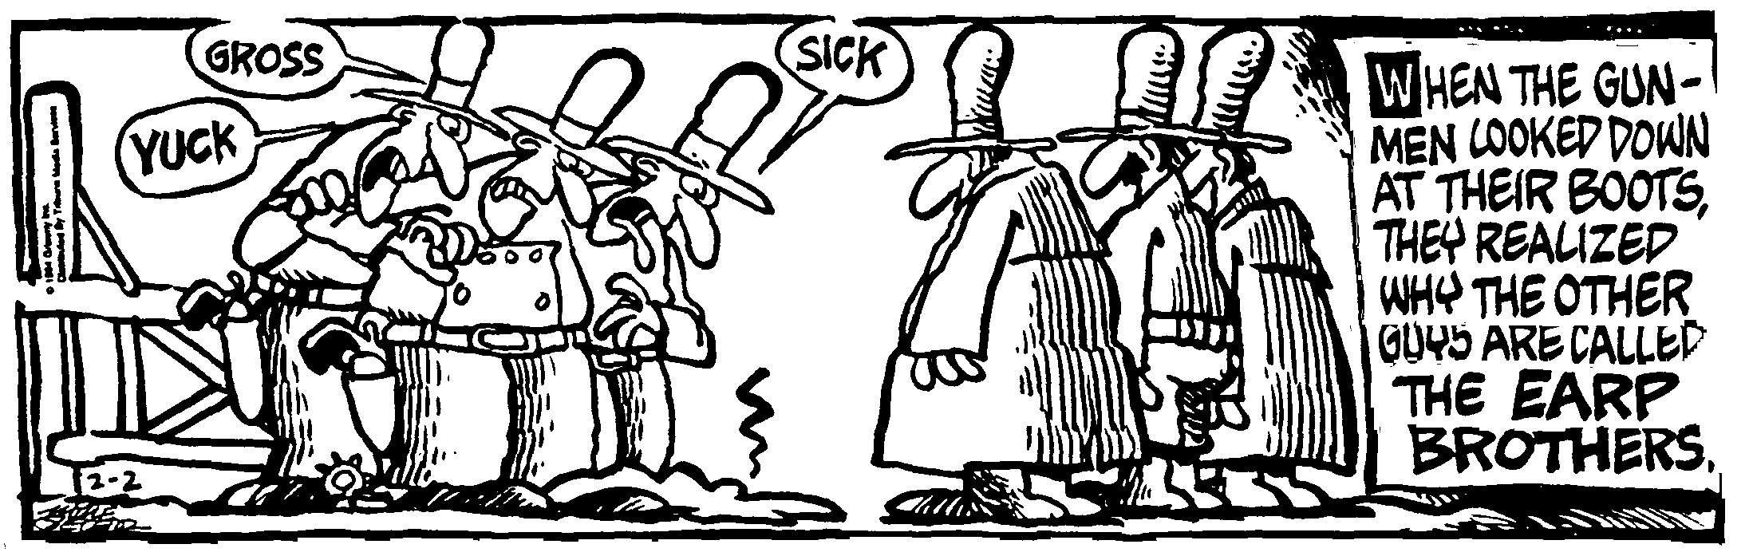
Flame______________________________________________________________________Per__
Unnamed Law of physics: If it happens, it must be possible.
1. (20) In which of the following situations would an object be accelerated?
I. It moves in a straight line at constant speed.
II. It moves with uniform circular motion.
III. It travels as a projectile in a gravitational field with negligible air resistance.

- I only
- III only
- I and II only
- II and III only
- I, II, and III

- (20) You are in a car going around a curve. The speedometer reads a constant 30 mph. Which of the following is not true?
- You and the car are accelerating.
- Your speed is constant.
- Your velocity is constant. (
- The magnitude of your acceleration is changing.
- The magnitude of your acceleration is constant.

- (20) A ball is thrown straight upwards. It rises to a height h and then falls back down. Ignore air resistance. Which of the following is true?
- the acceleration at the top of the path is zero.
- The acceleration is positive in the first half of the motion and negative for the second half of the path.
- The direction of the acceleration is always the same as the direction of the velocity.
- The direction of the velocity is constant.
- The direction of the acceleration is constant.

- (20) A train travels from Hooterville to Chattanooga in 3 hours and 19 minutes. If the average speed for the train was 88.5 km/h, how much distance did it cover?

- (40) You travel down the highway, starting from rest. You travel for 3.0 hours at a speed of 50 mi/h. Then you stop and eat your lunch for 30.0 min. You then travel for 30 min at 75 mi/h, discover you left your backpack at the restaurant, make a U-turn, go back and get it, taking the same amount of time with the same speed. Then you resume your journey, traveling at 50 mi/h for 3 hours. Make a distance Vs time graph of this motion.

- (40) You are on top of a building that is 85.0 m tall. You toss a ball straight up with an initial velocity of 27.5 m/s. (a) How high does the ball travel? It goes up and then falls down to the ground below. (b) How much time is it in the air?

- (60) A cart travels along a straight section of track. A velocity vs time graph illustrating its motion is graphed to the right.
- Indicate every time t for which the cart is at rest.

- Indicate every time interval for which the speed (magnitude of velocity) of the cart is increasing.

- What is the acceleration from a – b?

- What is the acceleration from b – c?

- What is the acceleration from c – d?

- What is the displacement after 7.0 s?

