AP Physics – Testing, One, Two - 5
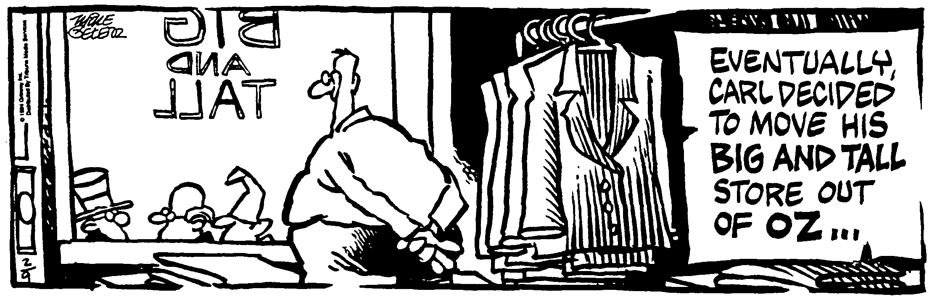
ID Opportunity__________________________________________________________________Per__
If at first you don't succeed, at least find out if the loser gets anything! -- Kristi Derrick
- (20) What is the momentum of a 540g macaw traveling at 18 m/s?

- (20) A planet is attracted to the sun with a certain force. If the distance from the sun to the planet is reduced by one half, what would happen to the force?

- (20) Astronauts in the space shuttle in orbit experience weightlessness. Does this mean that there is no gravity in space? Explain what is going on.

- (20) You weigh 625 N on earth. What would you weigh on Venus? Venus' mass is 4.88 x 1024 kg and it has a radius of 6.07 x 106 m.

- (20) An 80.0 kg astronaut in space throws a 10.0 kg oxygen tank away from herself. If the recoil speed of the astronaut is 1.52 m/s, what was the velocity given to the oxygen tank?

- (40) Neptune is 4.50 x 10¹² m from the sun. The sun's mass is 1.99 x 1030 kg. Neptune’s mass is 1.03 x 10²⁶ kg. (a) What is the orbital velocity of this distant planet? (b) What is its period in units of years?

