Physics – Is This an Energetic Test? - 4

Okay, who are you?________________________________________________Per__
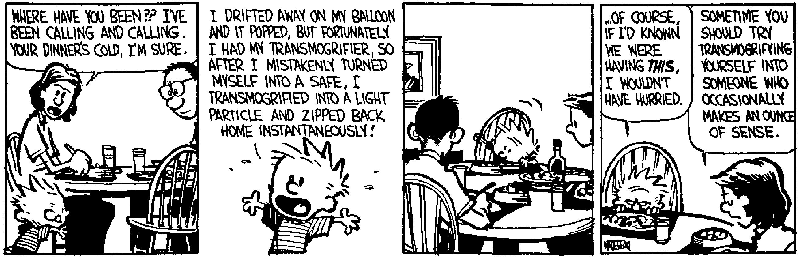The rules of conduct, the maxims of action, and the tactical instincts that serve to gain small victories may always be expanded into the winning of great ones with suitable opportunity; because in human affairs the sources of success are ever to be found in the fountains of quick resolve and swift stroke; and it seems to be a law inflexible and inexorable that he who will not risk cannot win. -- John Paul Jones
- (20) How much work is done on a 45.6 kg rock that you lift 0.85 m?

- (20) You apply a 325 N force to a heavy crate with a rope that makes a 29.0° angle with the horizontal, if you pull the crate a distance of 5.37 m, how much work was done?

- (20) A Wookie with a mass of 518 kg runs up a hill. At the top of the hill, he has 57.5 kJ of potential energy. How high was the hill?

- (50) Sitting on a table that is 85.5 cm above the deck is a spring that has a spring constant of k = 455 N/m. The spring is compressed a distance of 11.5 cm with a 0.756 kg ball. (a) What is the kinetic energy stored in the spring? (b) When the ball is released, what is the velocity of the ball? (c) When the ball rolls off the table, how much time does it take till it hits the deck? (d) How far does the ball travel horizontally from the edge of the table before it hits the deck? (e) What is the kinetic energy of the ball just before it hits the deck?

- (20) A roller coaster starts at some height that you do not know. It goes down this hill and then goes up a second hill that is 29.7 m above the first drop. At the top of this hill, it has a speed of 28.5 m/s. So how high was the initial hill?

- (20) The Batman runs up a 9.5 m bat ladder. The Caped Crusader has a mass of 52 kg and is carrying 15 kg of crime fightin’ gear. If the super hero developed 1 685 watts, how much time did it take to reach the top of the bat ladder?

- A 37.3 kg crate slides down a ramp. The ramp is 3.20 m long and is at a 37.0° angle. The crate starts from rest. It experiences a constant frictional force of 12.0 N as it slides downwards. What is the speed of the crate when it reaches the bottom?

- A reasonably svelt Tarzan at 56.2 kg stands atop a branch in the African rain forest. He grabs this 28.7 m long vine and swings out. Initially the vine made an angle of 33.0° to the vertical. How fast will the mighty Lord of the Apes be traveling when he reaches the bottom of his swing?

