Physics – Is This an Energetic Test? - 4

Okay, who are you?_________________________________________________Per__
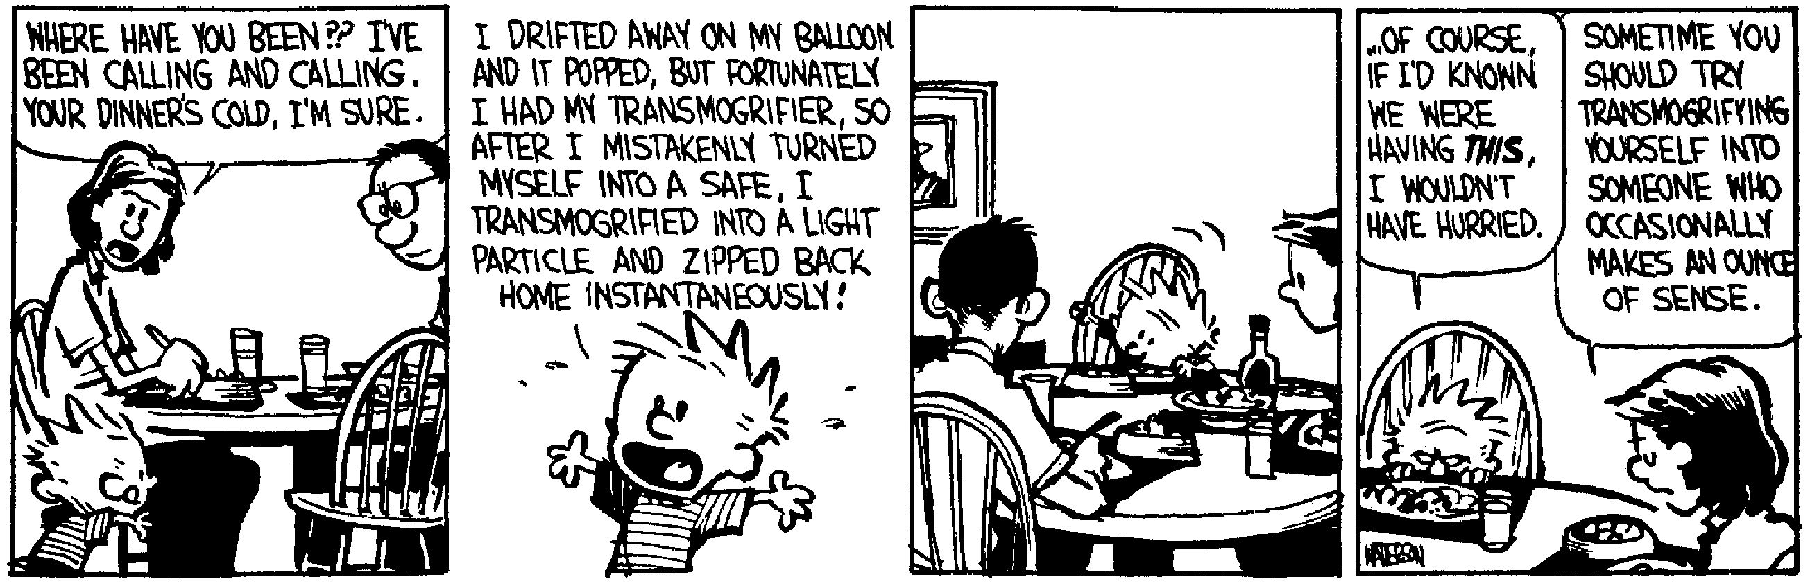
The rules of conduct, the maxims of action, and the tactical instincts that serve to gain small victories may always be expanded into the winning of great ones with suitable opportunity; because in human affairs the sources of success are ever to be found in the fountains of quick resolve and swift stroke; and it seems to be a law inflexible and inexorable that he who will not risk cannot win. -- John Paul Jones
- (20) You apply a 325 N force to a heavy crate with a rope that makes a 29.0° angle with the horizontal, if you pull the crate a distance of 5.37 m, how much work was done?

- (20) The Batman runs up a 9.5 m bat ladder. The Caped Crusader has a mass of 52 kg and is carrying 15 kg of crime fightin’ gear. If the super hero developed 1 685 watts, how much time did it take to reach the top of the bat ladder?

- (20) A 0.250 kg baseball traveling at 50.0 m/s is caught in a fielder’s mitt. If the ball takes 0.0498 seconds to come to a stop in the mitt, what average force was exerted on the ball?

- (50) Sitting on a smooth table that is 85.5 cm above the deck is a spring (spring constant = 455 N/m). The spring is compressed a distance of 11.5 cm with a 0.756 kg ball. (a) What is the potential energy stored in the spring? (b) When the ball is released, what is the velocity of the ball? (c) When the ball rolls off the table, how much time does it take till it hits the deck? (d) How far does the ball travel horizontally from the edge of the table before it hits the deck? (e) What is the kinetic energy of the ball just before it hits the deck?

- (40) A 4.0 kg ball starts from rest and rolls down a ramp a distance of 0.50 m as shown and collides with a 2.2 kg ball this is at rest. The first ball ends up going backwards in the opposite direction with a speed of 0.48 m/s. Assume all surfaces are really really smooth. (a) What is the velocity of the first ball at the bottom of the ramp? (b) What is the velocity of the second ball (the 2.2 kg one) after the collision? (c) How far back up the ramp does the first ball travel before it stops? (d) If the spring is compressed 10.0 cm by the second ball (as shown below in the drawing), what is the spring constant?

