AP Physics – Newton’s Laws Test - 3
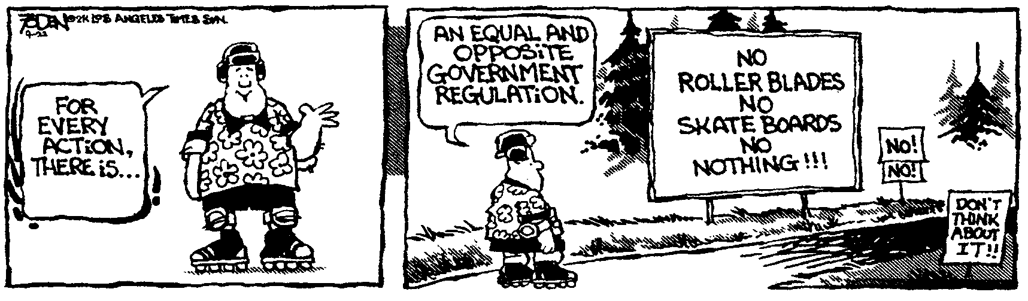
You is? _________________________________________________________________Per___
Every man takes the limits of his own field of vision for the limits of the world. -- Arthur Schopenhauer
- (20) Batman throws a bat grenade at an angle of 44.0° to the horizontal with a speed of 17.8 m/s (the Batman has a pretty good arm). How far does it travel?

- (20) What is the mass of a 335 N aardvark?

- (20) What net force is needed to accelerate a 2350 kg car at 4.80 m/s²?

- (20) When you jump into the air, you push the earth away from you and the earth pushes you away from it. How come no one notices that you pushed the earth?

- (20) A 2 350 kg gold nugget hangs from two cables which are at the angles shown. Calculate the tensions in the two cables.

- (20) Two masses are connected by a light string which passes over a frictionless pulley as shown. (a) What is the acceleration of the system? (b) What are the tensions in the string?

- (20) You pull on a 98.0 kg box of bat pineapples and drag it across the a deck. If the coefficient of kinetic friction for the box and the deck is 0.405, what force must you apply to move the thing at a constant speed?

- (20) A Find the acceleration of the system shown in the drawing if the coefficient of kinetic friction between the 7.80 kg mass and the plane is 0.316.

- (20) Why do all objects fall at the same speed (ignoring air resistance)?

- (20) The first law says that no force is required to maintain motion. Fine, then how come you have to keep pedaling your bicycle to keep it moving?

