AP Physics – The Wretched Vector Test

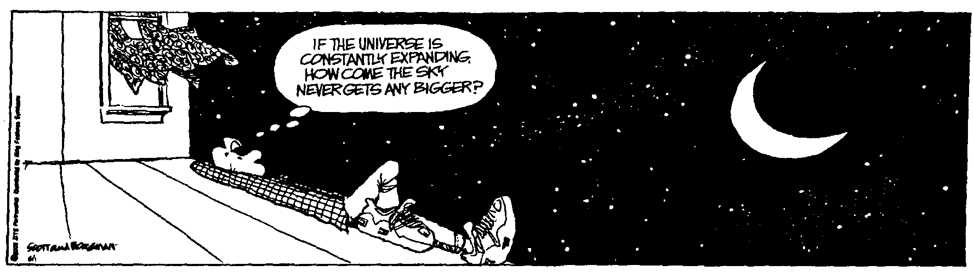
Presto ____________________________________________________________________Per ___
Nearly all men can stand adversity, but if you want to test a man's character, give him power. -- Abraham Lincoln
- (20) You walk east for 2.5 km and then north for 3.8 km. What is the magnitude of your resultant displacement?

- (20) A ball is thrown with an angle of 25.0 ° to the horizon with a speed of 18.0 m/s. What are its horizontal and vertical components?

- (20) The Batmobile runs straight off a cliff. It is traveling at a speed of 104.5 m/s when if leaves the road. If the cliff is 25.5 m high, how far horizontally does the car travel before it smashes into the ground below?

- (20) Capt Hornblower on the good ship HMS Herpes fires a cannon at a Spanish Pirate. The cannonball has a velocity of 125 m/s at an angle of 28.5° to the horizontal. Neglecting air friction, what is the horizontal range of the shot?

- (20) A 16 inch projectile is fired at an enemy light cruiser. If the thing travels a distance of 33 500 m in 85.5 s, what was the projectile’s initial velocity (i.e., speed and angle with the horizontal)?

