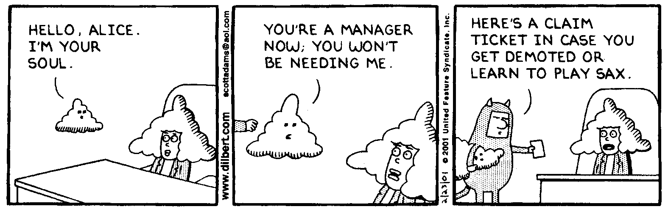
AP Physics – Oh no! It’s a Nuke Test!

You Know Who_______________________________________________________________Per__
I do not know what is wrong with Heisenberg. He seems so sure of himself lately. -- Sydney Harris

- (20) Determine the number of protons, electrons, and neutrons each of these isotopes possesses: and

- (20) A beam of light, wavelength 525 nm in air, is incident on a block of glass (n = 1.51) at an angle of 30.5°. Find (a) the angle of refraction, (b) the wavelength of the light in the glass.

- (20) Construct the image for an object placed as shown below.

- (20) A double convex thin lens has a focal length of 25.0 cm. A 3.30 cm tall object is placed 38.0 cm from the lens, find (a) the image distance, (b) the magnification, (c) the image height.

- (20) The distance between two slits is 0.0500 mm and the distance to the screen is 2.50 m, find the spacing between the central bright fringe and the first-order fringe. Figure yellow light with a wavelength of 580.0 nm

- Complete the following nuclear reactions:

(a)

(b)

- (20) What is the energy of a photon with a wavelength of 435 nm?

- (60) Light of wavelength 350.0 nm is incident on a metal surface. Electrons are emitted that have a maximum kinetic energy of 1.25 eV. Find (a) the work function of the metal, (b) the cutoff wavelength, and (c) the cutoff frequency.

- (60) A monotomic gas is illuminated with visible light of wavelength 412 nm. The gas is observed to absorb some of the light and subsequently to emit visible light at both 412 nm and 675 nm.
(a) In the box at the side, complete an energy level diagram that would be consistent with these observations. Indicate and label the observed absorption and emissions.

(b) If the initial state of the atoms has energy –5.50 eV, what is the energy level for the 412 nm light?

(c) At which other wavelength(s) do these atoms emit radiation after they are excited by the 412 nm light?

