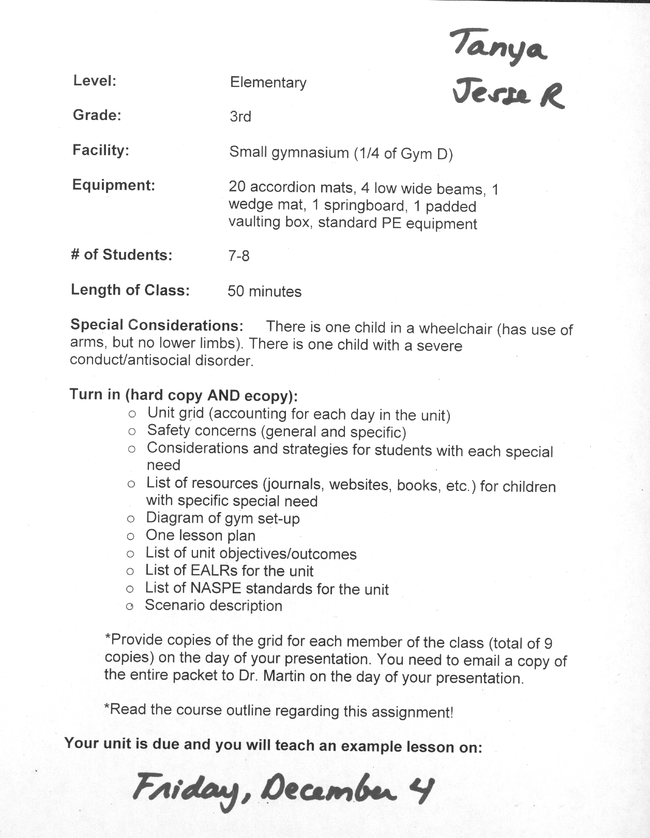
Day One: UPRIGHT BALANCE  *GYM SETUP A  Equipment: 8 AM  Safety: General  Entry/Stretch:  Neck stretching, leg stretches, arm stretches  Review:  - Crab sit  - Knee balance  Teach/Activity:  - V-sit  - Front support balance  - One-foot balance  - Practice on both L & R feet | Day Two: FALLING AND LANDING  *GYM SETUP A  Equipment: 8 AM  Safety: General  Entry/Stretch  Review:  - Back rocker (start from squat, standing)  - Seat roll (both directions)  - Puppy dog roll (both directions)  Teach/Activity:  - Dog roll (both directions)  - Sit back from squat (both directions)  - Sit back to dog roll (both directions)  Independent practice:  - Students practice progressions with teacher and then practice what is comfortable | Day Three: FORWARD ROLLING  *GYM SETUP A  Equipment: 8 AM, 8 bean bags  Safety: General  Entry/Stretch:  - Neck stretching most critical  Review:  - Back rocker  - The “look behind” with bean bags under chin  Teach/Activity:  - Tip over with chin to chest  - Forward roll from squat, standing at end of mat  Independent Practice:  - Students practice forward rolling from comfortable position (squat or standing) | Day Four: BACK SHOULDER ROLLING  *GYM SETUP A  Equipment: 8 AM  Safety: General  Entry/Stretch  Review:  - Back rocker  - Back balance  - Back rocker to puppy dog (both directions)  Teach/Activity:  - Back rocker  - Dog roll  - Back rocker to dog roll (both directions)  - Back shoulder roll (both shoulders)  Independent practice:  - Students practice shoulder roll w/ comfortable shoulder
Day Five: INVERTED BALANCE  *GYM SETUP A  Equipment: 8 AM  Safety: General  Entry/Stretch  Review:  - Hand positions  - Head touch (make triangle)  - Raise hips  - Knee meets elbow  - Tripod  Teach/Activity:  - One free knee  - Double free knee | Day Six: UPRIGHT AGILITY  *GYM SETUP A  Equipment: 8 AM  Safety: General  Entry/Stretch  Review:  - Find focus spot on wall  - Knee slapper  - Ankle slapper  Teach/Activity:  - Seat kicker  - Straddle jump, star jump  - ¼ turn, ½ turn  Independent Practice:  - Find focus spot on wall and practice each 5 times | Day Seven: INVERTED AGILITY  *GYM SETUP A  Equipment: 8 AM  Safety: General/ Partners  Entry/Stretch  Review:  - Hand position with respect to body positioning  - Leg lifter (both legs)  - Leg switch (begin on both legs)  Teach/Activity:  - Kick up (start standing)  - Switcheroo (one leg lifted, switch legs in air w/ partners)  - Barrel roll (both directions) | Day Eight: BALANCING ON LWB  *GYM SETUP B  Equipment: 8 AM, 4 LWB, Floor Tape, 5 Beanbags  Safety: General/ Specific for LWB  Entry/Stretch  Review:  - Step on and over  - Balance on  - Step to the side  Teach/Activity:  - Walk forward  - Slide to the side  - Walk and pivot  Independent Practice:  - Practice any skills learned today or previously
Day Nine: VAULTING ON LWB  *GYM SETUP B  Equipment: 8 AM, 4 LWB, Floor Tape, 5 Bean Bags  Safety: General/ Specific for LWB  Entry/Stretch  Review:  - Front support  - Side step  Teach/Activity:  - Step over  - Kangaroo jump  Independent Practice:  - Practice any of the activities taught today or previously | Day Ten: JUMPING/TURNING ON SB  *GYM SETUP C  Equipment: 8 AM, 1 LWB, 1 SB, 1 WM  Safety: General/ Specific for SB  Entry/Stretch  Review:  - Jump off  - Knee slapper  - Seat kicker  Teach/Activity:  - Straddle jump, star jump  - ¼ turn, ½ turn  Traditional Stations:  - Wedge mat, sequences, springboard, low wide beam  - Change activities second time around | Day Eleven: PVB  *GYM SETUP D  Equipment: 8 AM  Safety: General/ Specific for SB  Entry/Stretch  Review:  - Barrel roll  Teach/Activity:  - Forward roll from box  - Forward roll from floor  Traditional Station:  - Sequences, springboard, low wide beam, padded vaulting box  - Change activities second time around | Day Twelve: Rotations  *GYM SETUP E  Equipment: 8 AM  Safety: General  Entry/Stretch  Review:  - Upright/ Inverted Balance  - Upright/Inverted Agility  - Forward/Backward Rolling  - Low Wide Beam  - Springboard  Sequence/Station:  - Wedge mat with rolling forward or backward, springboard, low wide beam, padded vaulting box  - Change activities second time around

Safety Concerns
General:
- No gum
- No jewelry
- No jeans
- No loose fitted clothing
- No buttons, strings or pockets on clothing
- Tuck in t-shirts
- Provide enough space for a “fall zone”
- Only one person on equipment unless otherwise specified
- Ask for a spotter when needed
- Socks are slippery on wood floors as well as on equipment

Specific:
Accordion Mat:
- Only one person per mat unless otherwise specified
- Make sure no gaps are between mats that are velcroed together
- Always make sure there is enough room to fall when performing a skill
- When completing sequences, start at the beginning of the mats and not the end.

Padded Vaulting box
- Be sure to close all gaps between mats
- Make sure all potential hazard areas are matted / padded
- The horse should be low enough for the children to jump only about chest high down
- Make sure the edges of the box are over the lips of mats

Low Wide Beam
- Always remember to check all spin locks
- Make sure all potential hazard areas are matted / padded (beam legs and supports)
- Landing areas from beams should be well padded and free of any clutter
- Beams should either be lowered or have mats stacked below them so they are no higher than chest level
- Provide for safe mounting and dismounting
- One person on at a time
- Have beams located away from walls
- No jumping off of beams unless specified

Springboard
- Only one person allowed on at a time
- Start on the springboard
- Next person cannot get onto springboard until the other person is off of the landing mat
- Only one pound, with both feet, unless otherwise instructed

Considerations and Strategies for Students with Special Needs
Child with Antisocial Disorder
Considerations/Strategies
- Be aware of what behaviors that the child exhibits
- Student may have limited academic skills, poor attention span and low levels of motivation
- Talk with the child’s parent to see what helps when any situation arises that may cause the child to behave in his/her disruptive behavior
- Show respect for students dignity even when the student engages in antisocial behavior
- Use individualized instruction and implement a knowledge of students’ learning style
- Focus on helping child achieve maximum success to create a positive learning environment
- During partnered activities, place student with a child who is successful in all aspects of activity and someone that will provide a positive example
- Give child positive reinforcement
Child in a Wheelchair
Considerations/Strategies
- Ask to child to see how comfortable he/she is getting in/out of his/her wheelchair
- Modify skills and alter teaching style to accommodate the needs of the child
- Child can perform balances while in their chair or down on the floor
- Asses child to see how much upper body strength he/she has to establish whether or not the child can perform skills in/out of wheel chair
- Always have a spotter or teacher readily available to help child with any task
- They can perform rolls or rotation movements by spinning their wheels and rotating through a vertical axis
- Create symmetrical and asymmetrical, wide and narrow shapes with arms and upper body
- Let the child know when gymnastics unit will occur within the year and give them an option if they are uncomfortable with the tasks
- Child can do upper body stretching with class and can simulate lower body stretches
- Have child hold a bean bag on his/her head, follow a line of tape on the ground from one end to the other, pivot or turn in the wheel chair and do the same things that could be done on a low wide beam

Unit Objectives
By the end of this unit the 3rd grade students will be able to
- Demonstrate the upright balance through the v-sit, front support balance or one-footed balance with 75% proficiency.
- Demonstrate falling and landing through the dog roll or sit back to dog roll with 75% proficiency.
- Demonstrate a forward roll from squat position with 75% proficiency.
- Demonstrate a back shoulder roll from squat position with 75% proficiency.
- Demonstrate inverted agility through a one-free knee or double-free knee position from the tripod balance with 75% proficiency.
- Demonstrate upright agility through the seat kicker, straddle jump, star jump, ¼ turn or ½ turn with 75% proficiency
- Demonstrate inverted agility through the kick-up, switcheroo or barrel roll with 75% proficiency.
- Demonstrate balancing on a low wide beam by walking forward, sliding side to side or walking and pivoting with 75% proficiency.
- Demonstrate vaulting on a low wide beam by stepping over, barreling rolling or kangaroo jumping with 75% proficiency.
- Demonstrate jumping from a spring board with a straddle jump or star jump with 75% proficiency.
- Demonstrate turning from a springboard with a ¼ turn or half turn with 75% proficiency.
- Demonstrate a forward roll on the padded vaulting box beginning on the floor or on the box with 75% proficiency.

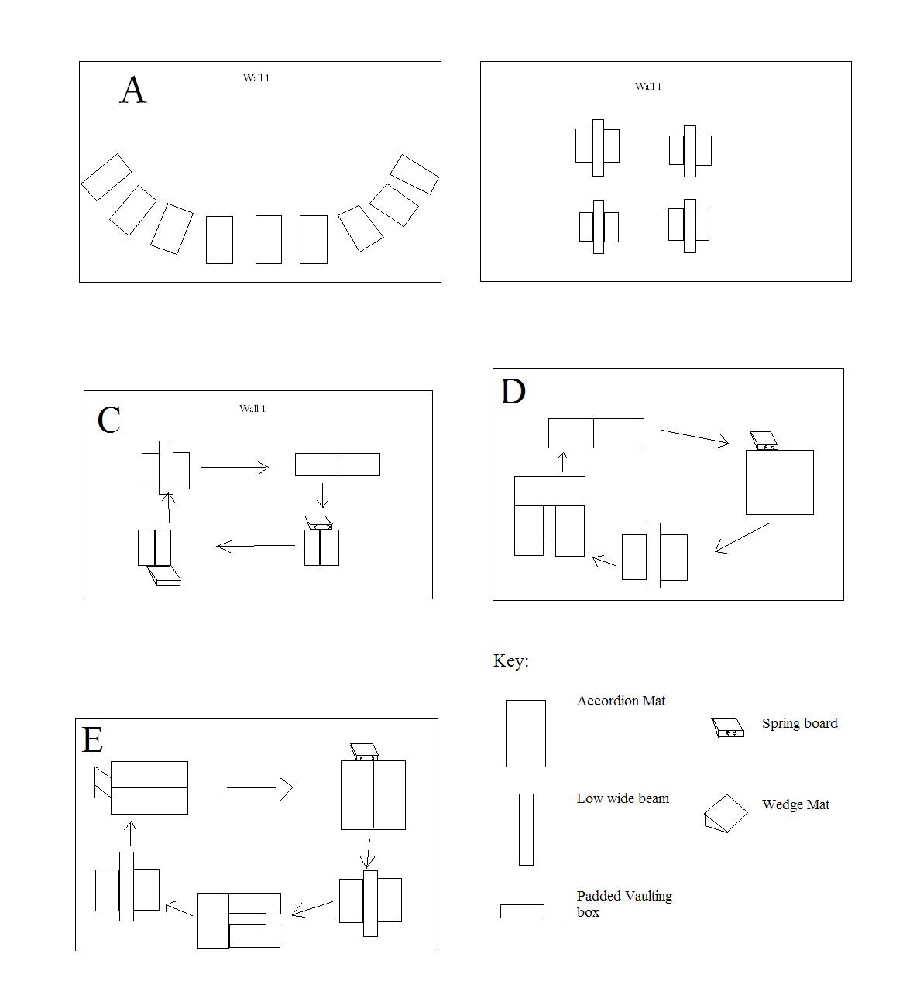
EALRs
1.1—Develops motor skills and movement concepts as developmentally appropriate.
1.2—Acquires the knowledge and skills to safely participate in a variety of developmentally appropriate physical activities.
1.4—Understands the components of skill-related fitness and interprets information from feedback, evaluation, and self-assessment in order to improve performance.
3.3—Evaluates the impact of social skills on health.
NASPE Standards
Standard 1: Demonstrates competency in motor skills and movement patterns needed to perform a variety of physical activities
Standard 2: Demonstrates understanding of movement concepts, principles, strategies, and tactics as they apply to the learning and performance of physical activities
Standard 5: Exhibits responsible personal and social behavior that respects self and others in physical activity settings
Standard 6: Values physical activity for health, enjoyment, challenge, self-expression, and/or social interaction
Resources
Abrams, B. (2005). Becoming a therapeutic teacher for students with emotional and behavioral disorders. Teaching Exceptional Children, 38(2), 40-45. Retrieved from http://escholarshi p.bc.edu/abstracts_tec/4/
Angie (Personal Communication, November 30, 2009).
D. Henrichs (Personal Communication, November 30, 2009).
J. Schaffer (Personal Communication, November 29, 2009).
Werner, P. (2004). Teaching Children Gymnastics. Retrieved from http://books.google.com/boo ks?id=-A-l03w7-I8C&dq=Teaching+Children+Gymnastics.+Peter+ Werner&printsec=frontcov er&source=bl&ots=Ej9qpMlddK&sig=swCk_TJO9m4QLz8-GoM9n HZ5seE&hl=en&ei=y1IY S5p4lfI1i6DQvAQ&sa=X&oi=book_result&ct=result&resnum=1&ved=0CAwQ6AEwAA#v=onepage&q=&f=false

Physical Education Lesson Plan by: Tanya Waller and Jesse Roberson
Date: December 4, 2009 Class: PE 340 Grade: 3rd Time: 10:00-10:50
Location: ¼ Gym D Number of Students: 7-8
Objectives of the Lesson: At the end of the lesson the 3rd grade students will be able to successfully complete demonstrate jumping from a spring board with a straddle jump or star jump with 75% proficiency and demonstrate turning from a springboard with a ¼ turn or half turn with 75% proficiency.
Procedures/Activities | Organization | Equipment | Time
Introduction: Tanya  - Welcome students, reminder of class rules  - Have students take off all jewelry and shoes, and go to mats, facing wall 1 | Standing scattered, seated on mats | 8 accordion mats | 0-2
Guided Practice: Jesse  - Dynamic stretching: students will mirror instructor’s stretches | Seated on mats | 8 accordion mats | 2-7
Explanation/Demonstration:  - Review one-footed balance: -knee lifter: find spot on wall to concentrate on, lift one knee, hold for 5 seconds  -bent hip scale: find spot on wall to concentrate on, lift one knee, bend forward, hold for 5 seconds  -extended hip scale: find spot on wall to concentrate on, lift one knee, bend forward until upper body is parallel to floor, hold for 3 seconds | Seated on mats | 8 accordion mats | 7-8
Guided Practice:  - Students will follow instructor as demonstrated: knee lifter, bent hip scale, and extended hip scale, repeat each one with opposite leg | Standing on mats | 8 accordion mats | 8-9
Explanation/Demonstration:  - Review forward rolling: -look behind: place both hands on mat, look through legs  -tip over: tuck chin to chest, transfer body weight to arms, roll | Seated on mats | 8 accordion mats | 9-10
Guided Practice:  - Students follow instructor as demonstrated | Standing on mats | 8 accordion mats | 10-11
Independent Practice:  - Students perform 5 forward rolls from squat position at instructor’s command | Standing on mats | 8 accordion mats | 11-12
Explanation/Demonstration:  - Review back rockers: start in squat position, hold knees, tuck chin to chest, rock backward | Seated on mats | 8 accordion mats | 12-13
Independent Practice:  - Students perform 5 back rockers from squat position at instructor’s command | Standing on mats | 8 accordion mats | 13-14
Explanation/Demonstration:  - Review back shoulder roll: start in squat position, tuck chin, roll to back, roll over shoulder, feet to mat, push up with hands | Seated on mats | 8 accordion mats | 14-15
Independent practice:  - Students perform 5 back shoulder rolls from squat position at instructor’s command | Standing on mats | 8 accordion mats | 15-16
Explanation demonstration:  - Review inverted balance: touch head to mat, place hands facing forward to make triangle with head, raise hips, bring one knee at a time to elbows to form tripod, lift one knee a few inches, then raise other | Seated on mats | 8 accordion mats | 16-17
Guided practice:  - Students follow instructor as demonstrated | Standing on mats | 8 accordion mats | 17-18
Explanation/Demonstration:  - Review upright agility:  -seat kickers: jump and bend knees, bring heels to seat  -straddle jump: jump and point legs and arms forward  -star jump: jump and point legs and arms outward  - ¼ turn: jump and turn body a quarter of a circle  - ½ turn: jump and turn body half a circle | Seated on mats | 8 accordion mats | 18-19
Independent practice:  - Students perform 10 upright agility skills of their choice at instructor’s command | Standing on mats | 8 accordion mats | 19-20
Explanation/Demonstration:  - Review inverted agility:  -kick-up: both hands on mat, both feet on mat, kick up with one foot  -switcheroo: both hand on mat, lift one leg in the air, kick up with other leg and switch in the air  -barrel roll: start standing, lead with left or right hand, whichever hand you lead with both hands will touch the mat before your feet do. (LH, RH, RF,LF or RH, LH, LF, RF) | Seated on mats | 8 accordion mats | 20-21
Independent practice:  - Students perform 5 inverted agility skills at instructor’s command | Standing on mats | 8 accordion mats | 21-22
Explanation/Demonstration: Tanya  - Introduce circuit stations 1-3  - Station #1:Sequences: upright balance, forward roll, upright agility, upright balance  - Station #2: Wedge mat: forward roll down mat, upright balance  - Station #3: Low wide beam: walk forward, pivot, walk forward, balancing bean bag on head, dismount  - Introduce and review spring boarding rules: stand near back of spring board, jump slightly forward and do one pound near front of spring board and bounce forward, keeping eyes forward throughout  - Station #4: Spring Board: star jump and straddle jump | Standing scattered | 1 wedge mat, 1 low wide beam, 1 spring board, 8 accordion mats | 22-25
Independent Practice:  - Students will be placed into partner groups and placed at different stations by instructors  - At instructor’s command, students will perform the designated skills at each station, alternating with their partner for 2 and a half minutes until instructor says “next station” in which the students will rotate clockwise (following the numbers) to the next station. Students will continue rotation until instructor commands. | Rotating through each station | 1 wedge mat, 1 low wide beam, 1 spring board, 8 accordion mats, music | 25-36
Explanation/Demonstration: Tanya  - Introduce new stations  - Station #1: Sequence #2: upright balance, forward roll, inverted balance, back shoulder roll, upright balance  - Station #2: Wedge mat #2: forward roll down mat, upright agility, upright balance  - Station #3: low wide beam #2: walk side to side, walk backwards  - Station #4: Spring board #2: ¼ turn and ½ turn | Standing scattered | 1 wedge mat, 1 low wide beam, 1 spring board, 8 accordion mats | 36-39
Independent Practice:  - Students will be placed at different stations  - At instructor’s command, students will perform the designated skills at each station, alternating with their partner for 2 and a half minutes until instructor says “next station” in which the students will rotate clockwise (following the numbers) to the next station. Students will continue rotation until instructor commands. | Rotating through each station | 1 wedge mat, 1 low wide beam, 1 spring board, 8 accordion mats, music | 39-49
Conclusion: Tanya & Jesse  - Congratulate students  - Ask what they enjoyed about lesson | Seated scattered | None | 49-50

Mastery of Objectives: The students will be assessed on their ability to perform the correct springboard skills during independent practice. The students will be observed by the instructors at the springboard station each time they perform a new skill. The students will be observed to see if they can correctly demonstrate springboard skills with 75% proficiency.

