2017 National PE & School Sport Institute Reduced Rate Program!
(Only $175 Vs. $300 Regular Price)
Background: This year, the National Physical Education & School Sport Institute will be offering each State AHPERD/SHAPE organization a reduced rate ($175) for up to four representatives to attend the 2017 PE Institute. The National Physical Education Institute will take place on July 24-26, 2017 at UNC Asheville.
Selection Criteria: The following info will be used in providing this special discount >
- The four individuals must be State AHPERD/SHAPE members in good standing.
- Not valid for individuals who have previously attended the PE Institute.

Duties: “Reduced Fee” participants will be expected to:
- Learn Twitter and Social Media Basics as to assist their fellow State physical education teachers with the variety of free lessons, tools, practices as determined by each State AHPERD/SHAPE
- Provide on-going mentoring assistance throughout the school year with follow-up PE Twitter Chats, webinars, and other social media events to be determined by each State AHPERD/SHAPE
- Write personal “True PE Stories” to chronicle the impact of social media and lessons learned at the National PE Institute as requested by PE Institute staff, and
- Serve as National PE Institute “Ambassadors.”
Submission Process: State AHPERD/SHAPE organization interested in applying for “Reduced Fees” must submit three items: (#1) the attached Screening Form, (#2) a written application addressing the four Duties seen above, (#3) and a completed registration form for each of the four Team Members to:
Artie Kamiya - Artie@greatactivities.net
PO Box 51158, Durham, North Carolina 27717

Questions? Contact Artie Kamiya - Artie@greatactivities.net or 919.818.6486.

Approval Timeline
• Approved State AHPERD/SHAPE organizations must submit a check or purchase order with their application for $175/participant. Fees are not refundable, but may be transferred as needed.
• Participants will be responsible for arranging travel, lodging, transportation to/from UNC Asheville, etc.
• Not valid if submitted after April 15, 2017.

--- Page 1 of 4 ---

2017 National PE & School Sport Institute “Reduced Fees” Screening Form
Yes, we are interested in sending a 4-member team to the 2017 Institute!

CHECKLIST:
____ Yes, we have filled out an individual registration form on each of the four individuals listed below. Please see Page 4 for this form.
____ Yes, we have completed the Application Form outlining how our Team will accomplish the “Four Duties” as listed on the previous page.
____ Yes, we have included a check/purchase order for our Team members ($175 per team member).

State AHPERD/SHAPE
Name of Executive Director
ED Address:
ED E-mail:
ED Cell Phone:
ED Home Phone:
Participant #1 (Team Leader)
Full Name
Summer Email:
Participant #2
Full Name
Summer Email:
Participant #3
Full Name
Summer Email:
Participant #4
Full Name
Summer Email:

--- Page 2 of 4 ---

Application Narrative (3 Page Limit)

Please use up to 3 pages to address how the four individuals listed in the previous page will work together to accomplish the following four duties:
- Learn Twitter and Social Media Basics as to assist fellow physical education teachers with the variety of instructional resources found via Twitter.
- Provide on-going mentoring assistance throughout the school year with follow-up PE Twitter Chats, webinars, and other social media events to be determined.
- Write personal “True PE Stories” to chronicle the impact of social media and lessons learned at the National PE Institute as requested by PE Institute staff, and
- Serve as National PE Institute “Ambassadors” as needed.

--- Page 3 of 4 ---

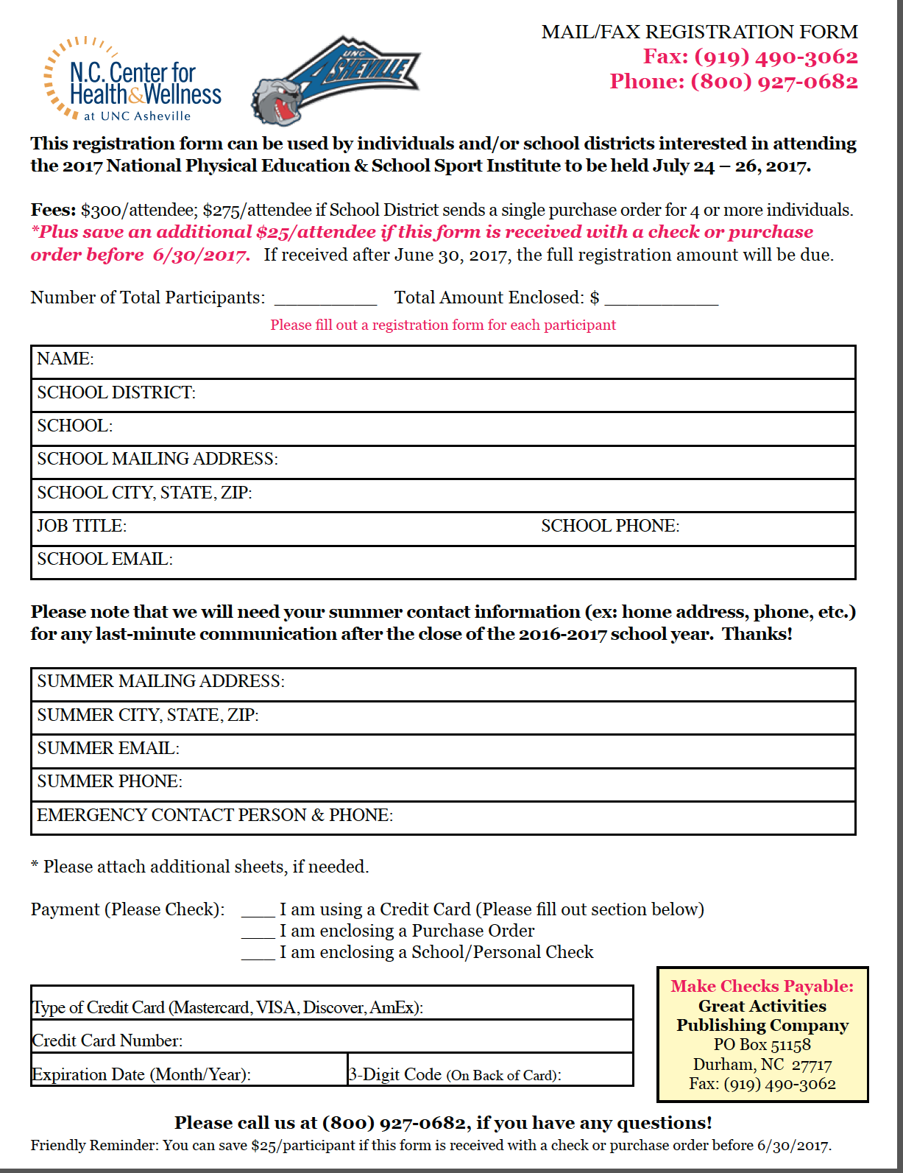
--- Page 4 of 4 ---
Reduced Fee Form for State AHPERD/SHAPE

