Laser Oscilloscope

Introduction: Using the principles of optical amplification, sound patterns can be projected on a distant wall and the principles of an oscilloscope can be demonstrated.
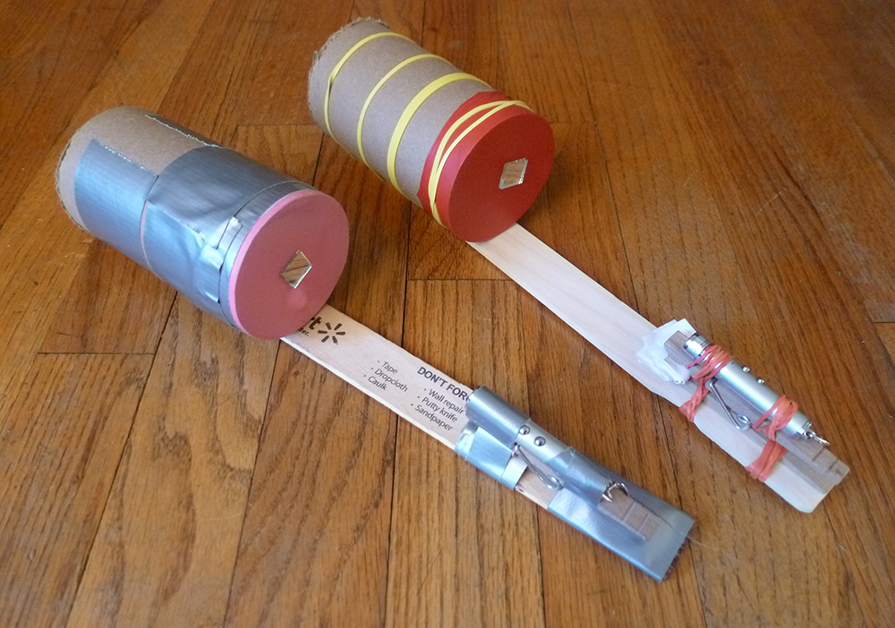

Materials:
Empty can
Playdoh
Glue
Balloon
Tape
Large Craft Stick
Rubber bands
Small Mirror
Laser

Procedure:

- Cut the bottom of the can out.
- Stretch the balloon tightly over one end of the can. Use the tape to hold it in place. It is important that the balloon is tight.
- Cut a small piece of the mirror into a square that is about 1 in by 1 in.
- Glue the mirror on the balloon half way between the side and the middle.
- Place the can on the craft stick and hold into place using the rubber bands.
- Put the lump of Playdoh on the craft stick and lay the laser on the Playdoh facing the small mirror. Position the laser so that it hits the mirror.
- Turn off the lights. Turn on the laser and observe the reflection off the mirror and onto a wall.
- Speak into the other end of the can and observe the pattern produced by the laser.

Conclusion:
- Sketch the pattern that is observed when you are speaking quietly into the can.

- Sketch the pattern that is observed when you are speaking loudly into the can.

- Sketch the pattern that is observed when you are singing a clear, set tone.

- Sketch the pattern that is observed when you cough loudly into the can.

- Thinking about the different pattern created by the alphabet, explain how automated computer phone systems can understand what you are saying. Also, explain why they don’t work for some people and are difficult for others.

