Organic Acid/Base Chemistry Lab
Preparation and Properties of Soap

Introduction

A soap is the sodium or potassium salt of a long-chain fatty acid. The fatty acid usually contains 12 to 18 carbon atoms. The source of the fatty acids is either from animal fats or vegetables which are esters of carboxylic acids. They have a high molecular weight and contained alcohol and glycerol. Chemically, these fats and oils are called triglycerides.

Solid soaps usually consist of sodium salts of fatty acids, whereas liquid soaps consist of the potassium salts of fatty acids. A soap such as sodium stearate consists of a nonpolar end (the hydrocarbon chain of the fatty acid) and a polar end (the ionic carboxylate).

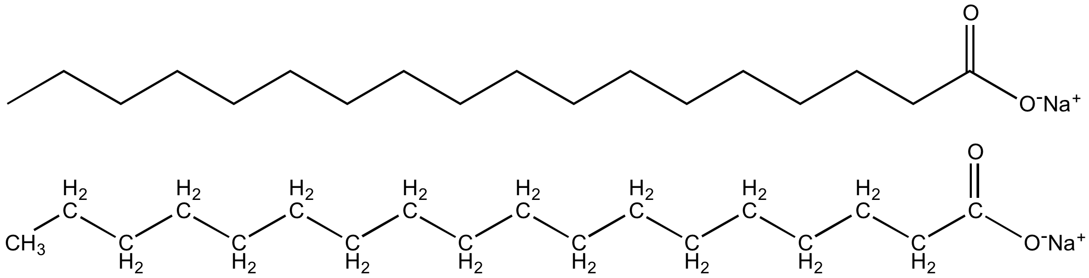

Nonpolar
Dissolves in oils/fats/grease
(Hydrophobic)
Polar
Dissolves in water
(Hydrophilic)

How soap cleans

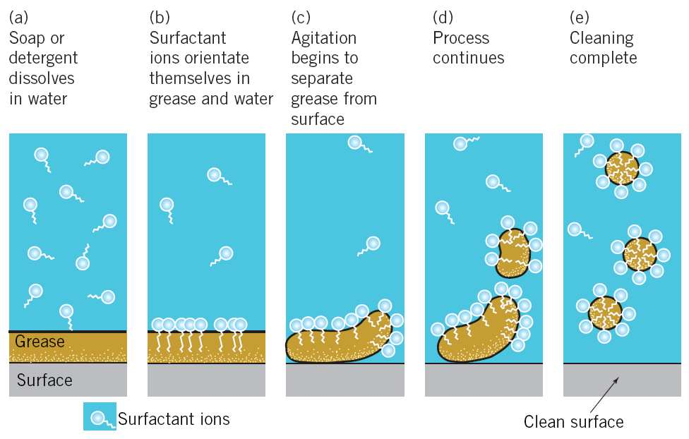

Soap bubble formation

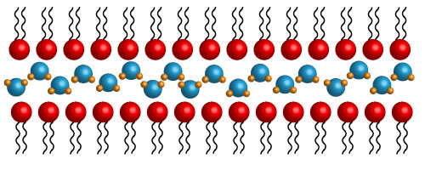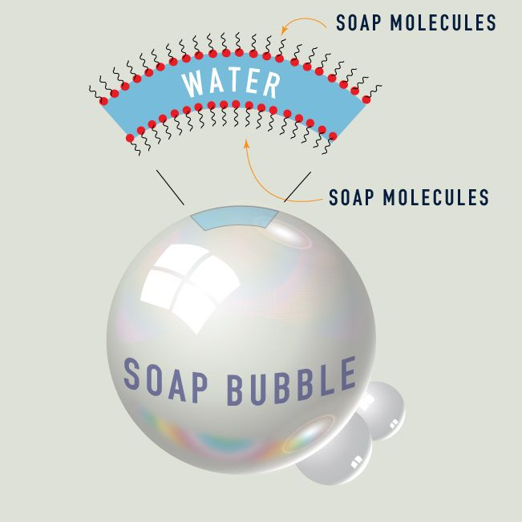

Because "like dissolves like" [Basically, this means polar molecules can dissolve other polar molecules (water dissolves table salt) and non-polar molecules can dissolve other non-polar molecules (gasoline can dissolve tar/oil), but polar molecules cannot dissolve non-polar molecules (water cannot dissolve oil/grease).] the nonpolar end (hydrophobic or water-hating part) of the soap molecule can dissolve the greasy dirt, and the polar or ionic end (hydrophilic or water-loving part) of the molecule is attracted to water molecules. Therefore, the dirt from the surface being cleaned will be pulled away and suspended in water. Thus soap acts as an emulsifying agent, a substance used to disperse one liquid (oil molecules) in the form of finely suspended particles or droplets in another liquid (water molecules).

Treatment of fats or oils with strong bases such as lye (NaOH) or potash (KOH) causes them to undergo hydrolysis (saponification) to form glycerol and the salt of a long-chain fatty acid (soap). Triglycerides glycerol sodium stearate (a soap)

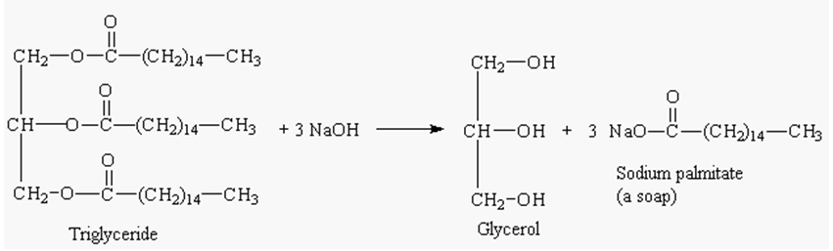

Natural fatty acids are rarely a single type in any given fats or oil. In fact, a single triglyceride molecule in a fat may contain three different acid residues (R₁COOH, R₂COOH, R₃COOH), and not every triglyceride in the substance will be identical.

The fats and oils that are most common in soap preparations are lard and tallow from animal sources and coconut, palm and olive oils from the vegetable sources. The length of the hydrocarbon chain and number of double bonds in the carboxylic acid salt of the carboxylic acid portion of the fat or oil determine the properties of the resulting salt. For example, the salt of a saturated long chain acid make a harder, more insoluble soap. Chain length also affects solubility.

Tallow is the principal fatty material used in making soap. The solid fats of cattle are melted with steam and tallow layer formed at the top is removed. Soap makers usually blend tallow with coconut oil and saponify this mixture. The resulting soap contains mainly the salts of palmitic, stearic and oleic acids from the tallow and the salts of lauric and myristic acids from coconut oil. The coconut oil is added to produce a softer, more soluble soap. Lard differs from tallow in that lard contains more oleic acids.

Pure coconut oil yields a soap that is very soluble in water. It is so soft that it will lather even in salt water. Palm oil contains mainly two acids, palmitic and oleic acid, in equal amount. Saponification of this oil yields a soap that is an important constituent of toilet soaps. Olive oil contains mainly oleic acid. It is used to prepare Castille soap.

Table 1 Structure of Acids Commonly Found in Soap
Acid | Structure
Palmitic acid | CH₃(CH₂)₁₄COOH
Stearic acid | CH₃(CH₂)₁₆COOH
Oleic acid | CH₃(CH₂)₇CH=CH(CH₂)₇COOH
Lauric acid | CH₃(CH₂)₁₀COOH
Myristic acid | CH₃(CH₂)₁₂COOH

Toilette soaps generally have been carefully washed free of any alkali remaining from saponification. As much glycerol as possible is usually left in the soap and perfumes and medicinal agents are sometimes added. Soft soaps are made by using potassium hydroxide, yielding potassium salts. They are used in shaving creams and liquid soaps.

Because soaps are salts of strong bases and weak acids, they should be weakly alkaline in aqueous solution. However, a soap with free alkali can cause damage to skin, silk, or wool. Therefore, a test for basicity of the soap is quite important.

Soap has been largely replaced by synthetic detergents during the last two decades, because soap has two serious drawbacks. One is that soap becomes ineffective in hard water; this is water that contains appreciable amounts of Ca² ⁺ or Mg² ⁺ salts.

2C₁₇H₃₅COO⁻Na⁺ + M²⁺ → [C₁₇H₃₅COO⁻]₂M²⁺_{(s)} + 2Na⁺
(Soap) (Scum)

(M = Ca²⁺ or Mg²⁺ (from “hard water”))

The other is that, in an acidic solution, soap is converted to free fatty acid and therefore loses its cleansing action.

Procedures for Baby Safe Chamomile and/or Lavender Soap

Equipment
To make this gentle bar soap you will need the following equipment (it’s best to keep these items only for soap making):
- a scale for measuring ingredients
- a stainless steel or enamel pot
- a glass or plastic pitcher for mixing and pouring the lye
- containers for holding oil while it’s being weighed – I use 32 oz plastic yogurt containers
- 2 large plastic or wooden spoons – one for stirring the lye and one for the oils
- a spatula
- 2 thermometers – one for the lye and one for the oil
- soap mold – this can be as simple as a shoe box lined with plastic, a plastic tray with sides, a plastic shoe box, or glass bread pans
- rubber gloves – wear these the entire time
- cardboard to fit over the molds
- a heavy towel or a blanket to insulate the cooling soap
- protective clothing – this is not a project for shorts and a tank top. Wear long sleeves and long pants to protect your skin.
- vinegar – I have this under equipment, rather than ingredients because it is not used in the recipe, but is kept on hand to pour on your skin if you accidentally get lye on you. Lye is extremely alkaline and can burn your skin and vinegar is acidic, so it will neutralize the lye. The first sensation you will feel if you get lye on yourself is an mild itch. Don’t panic, just dab some vinegar on the area and all will be well.

Ingredients (Modified ¼ from original recipe)
Weigh the following ingredients on the scale. Please note that these are not liquid measurements:
- 0.75 oz coconut oil (21.2621g)
- 0.25 oz jojoba oil (7.0874g)
- 6.25 oz olive oil (177.1845g)
- 0.93 oz lye (26.3651g)
- 2.5 oz distilled water (70.874g = 70.874mL)
- 0.125 oz (3.54g) chamomile or lavender essential oil, or 0.0625 oz (1.772g) of each

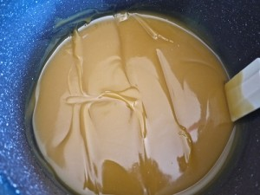
1. Fill your sink with several inches of cold water and some ice to use as a water bath to cool the lye mixture.
2. Wearing your rubber gloves, place the 2.5 oz (70.874g = 70.874mL) of distilled water into your pitcher and very slowly stir in the lye. I suggest doing this outdoors since even the fumes are toxic. Stir slowly until dissolved. The temperature will rise very quickly to 220°F (104.44ºC) or so. Now place the pitcher into the cold water bath in your sink and begin to take its temperature. The goal is 100°F (37.78ºC) .
3. Then place all the oils, except the lavender and chamomile, into your pot and heat at a low temperature trying to reach 100°F (37.78ºC). This will happen quickly. You now want to get both the lye and the oil to 100°F (37.78ºC) at the same time. This is one of the trickiest parts of soap making. Use the ice water bath to help lower the temperatures as needed.
4. When both the lye and the oils are at 100°F (37.78ºC), pour the lye mixture very slowly into the oil mixture. Continue stirring with a spatula until the mixture reaches a point called “trace”. The soap is traced when your stirring causes lines in the mixture that stay in place or when a drizzle of the soap mixture retains it shape on the surface of the soap. Trace can take up to 2 hours or more, but usually occurs within a half hour. If it is taking over 15 minutes, you may take breaks in stirring – stir for 10 minutes or so and rest for 10 minutes.
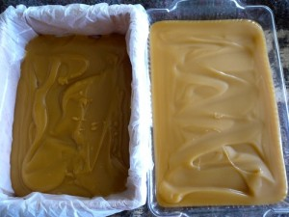
5. At trace, add in the 0.125 oz (3.54g) of essential oils and stir well. Then pour your soap into your prepared molds. Cover with the piece of cardboard and then wrap in a towel or blanket to hold the heat. You want your soap to cool slowly. You may remove the towel after the first day, but the soap itself will take several days to harden. Super-fat soap is a soft soap that takes longer to cure than recipes that are not super-fatted. When it feels solid, you may cut the soap into bars and un-mold it. The soap is still alkaline and should not be used until it has cured for 6 weeks.

