Introduction to Solar Power and Solar Panels
First, watch this 2 minute video to get an overview of how solar panels work https://www.youtube.com/watch?v=0elhIcPVtKE

Then, use this infographic to answer the questions on the back of this page
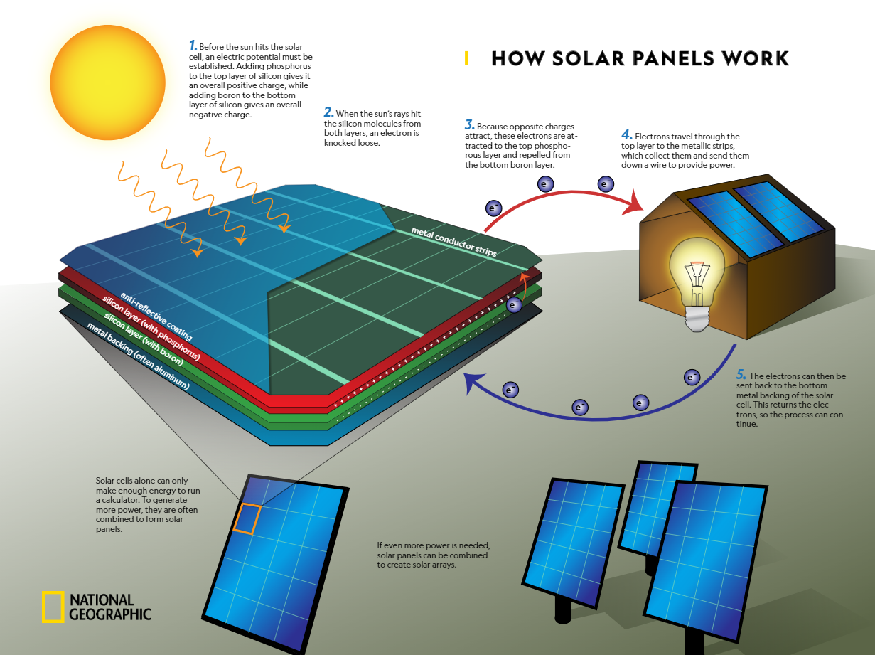

Questions:
- What is a simplified, general idea of what solar panels do?

- How is this process similar to how a battery works?

- Do you think that solar panels work during cloudy days? Why or why not?

Finally, read this article about the best ways to make solar panels efficient. https://www.energy.gov/articles/getting-most-out-solar-panels

Based on your reading, suggest a location where Lake Howell could install solar panels. Support your answer with evidence from the article. This should be in at least 5 complete sentences.

