Soap Bubbles Interference
- The colors of a soap bubble come from reflections of the white light that falls on the bubble.
- White light, such as from the sun or from a light bulb contains light of all colors.
- Light has waves, and the length of the wave, from crest to crest, determines the color of the light.
- Interference between waves occurs whenever waves travel through the same space. Interference occurs when two rocks are tossed near each other into a lake. Circular waves on the surface of the water spread out from where each rock entered the water. Where the crests of two waves meet, interference between the waves causes the motion of the surface of the water to increase. Where a crest and a valley meet, interference reduces the motion of the water's surface. Similar interference can occur in waves of light.
- Waves of light reflected from the inner and outer surfaces of the film of a soap bubble can interfere with each other. Where the crests of the light waves reflected from the inner and outer surfaces of the film meet, the intensity of the light increases.
- If the crest of a wave reflected from the inner surface meets the valley of a wave from the outer surface, the intensity of the light will be diminished.
Procedure:
  - Make a bubble wand from the wire.
  - Make a bubble and observe the colors.
  - Shine a bright light on the bubble and create the bubble pattern on a sheet of paper.
  - Look closely for dark or black spots appearing on the bubble and on the paper.
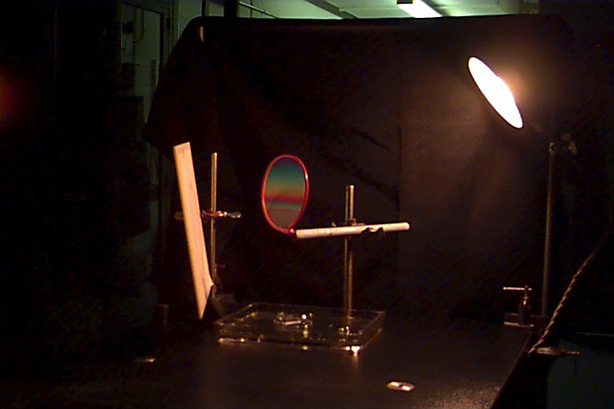
Conclusion:
- What causes the different colors to form on the bubbles?

- What determines the color of light?

- What is constructive interference?

- What is destructive interference?

- What causes the bright or shiny spots on the bubbles?

- What causes the dark or black spots for form on the bubbles?

- Sketch a drawing of what was projected on the white sheet of paper.

