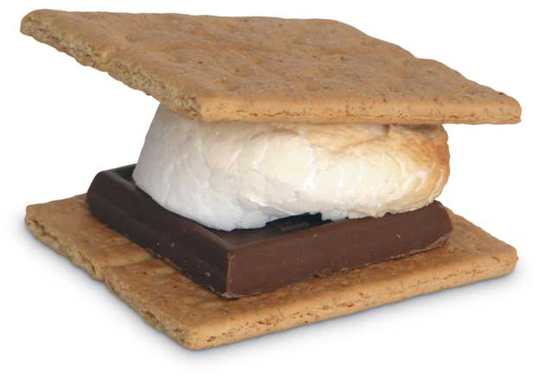
Name:__________________________
Date:___________________________
Period:__________________________

S’mores Lab

Although this lab will be fun and good to eat, it requires some thought and hard work!

**Be sure to remember all your facts about thermal energy transfers**

Procedure:

You will be responsible for writing the listed procedure for this lab. You can use a bulleted format, but you must explain all the processes which go into the lab. The procedure must be written in Past Tense and no pronouns. (Example: Placed the marshmallow into the open flame of the Bunsen burner). I have provided bullet points, below you do not need to use all of them, but the procedure needs to be a complete lab procedure!

Questions:

- What thermal energy transfer(s) occurred in this lab?

- Based on your answer above, where did the transfer(s) occur in relation to the flame and on the marshmallow? Explain in DETAIL where this transfer occurred.

- What form of energy started the heating process (chemical, electrical, thermal, nuclear, or radiant). ***Hint: think about the gas***

- a. Where did the marshmallow get its thermal energy from?

b. What about the chocolate? (It is different than above) AND which type of thermal energy transfer caused this to happen?

- Make an observation about the size of the marshmallow before and during the cooking process. Do you think you can ever “un-cook” the marshmallow?

- Please give one non-s’more related example, of convection, conduction, and radiation.

