Slinky Lab – Understanding Waves
Materials:
2 Slinkys (one heavier wire than other)
Stopwatch
String
Masking Tape
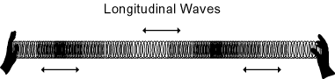
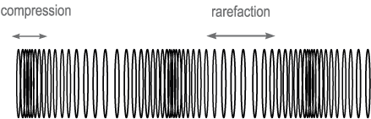

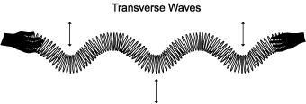
Procedure:
Each team has 3 students: one serves as the “shaker ”, one as the “holder ” and one as the “observer/recorder” that films the movement of the slinky.
1. With a partner to help pull the slinky out on the table. With your free hand, grasp the stretched spring about a meter from one end. Pull the meter of spring together toward yourself and then release it, being careful not to let go of the fixed end with your other hand! Observe the movement of the single wave, called a pulse, travel along the spring. In such a longitudinal pulse, the spring coils move back and forth along the same direction as the wave travels. The wave carries energy, but the spring remains stationary after the pulse has passed through it and reflected from the other end.

Describe what you observe and draw a sketch below:

2. Create a transverse wave. Practice moving your hand very quickly back and forth at right angles to the stretched spring until you can produce a pulse that travels down the spring. This is called “transverse” because the individual coils of wire move at right angles to (transverse to) the length of the spring.

Describe what you observe and draw a sketch below:

3. Next observe what happens when waves go from one material to another - called refraction. Attach the different kind of spring to one end of your spring and have your partner hold the end of it. Make a transverse wave and record what happens when the wave reaches the boundary between the two springs.
Describe what you observe and draw a sketch below:

4. Have your partner detach the extra spring and once more grasp the far end of your original spring. Have him send a pulse on the same side at the same time you do, so that the two pulses meet.
Describe what you observe and draw a sketch below:

5. By vibrating your hand steadily back and forth,you can produce a train of pulses, or a periodic wave. The distance between any two neighboring crests on such a periodic wave is the wavelength. The rate at which you vibrate the spring will determine the frequency of the periodic wave. Produce various short bursts of periodic waves so that you can answer the following question. How does the wavelength depend on the frequency?

6. Put strips of masking tape about ½ meter apart on the floor. Continue the process until you have a length of about 6 meters marked off. This will serve as your “measuring line”. Have 2 team members sit at the opposite ends of the measuring line.
- Stand beside the measuring line roughly at mid-length of the slinky.
- The 2 partners at the end should hold the slinky at opposite ends and one partner makes waves as the other partner holds his/her end still.
- Once the Wave Maker gets into a consistent motion of making a wave, the partner holding the other end of the slinky should observe and record the wavelength and frequency in the table.
- Calculate the number of crests per second and enter the result in the appropriate column.
- Repeat steps 4-8 one more time. In the beginning, produce the longest wavelength then produce a very small wavelength.
Trial | Wavelength | # Crests in 10 sec | Calculated # of crests in 1 sec
Small Wavelength
Long Wavelength
Using the data table, plot the frequency (in crests per second) versus the wavelength. Explain the relationship that you observe.

