Name:_________________________________
Class Period:_______________
Skeletal System Test
Write your answer in the blank to the left of the number
_____ 1. The tough, fibrous outermost covering of the bone is the _____.

A) Compact Bone B) Periosteum C) Cartilage D) Marrow
_____ 2, The small bone anterior to the knee joint is the _____.

A) Radius B) Tibia C) Femur D) Patella
_____ 3. The number of pairs of ribs is _____.

A) 12 B) 7 C) 5 D) 24
_____ 4. The bones between the ankle joint and toes are _____.

A) Metacarpals B) Phalanges C) Tarsals D) Metatarsals
_____ 5. The shoulder is a _____ joint.

A) Hinge B) Pivot C) Gliding D) Ball & Socket
_____ 6. The hard, dense, and very strong bone that forms the outer layer of bone is _____ bone.

A) Spongy B) Periosteum C) Compact D) Long
_____ 7. The longest bone in the body is the _____.

A) Femur B) Vertebral Column C) Humerus D) Tibia
_____ 8. The number of phalanges is _____.

A) 10 B) 14 C) 22 D) 20
_____ 9. The knee is a _____ joint.

A) Hinge B) Pivot C) Gliding D) Ball & Socket
_____ 10. The forearm bone on the pinkie side of the arm is the ____.

A) Radius B) Ulna C) Fibula D) Humerus
_____ 11. The term that means inflammation of a joint is _____.

B) Sclerosis B) Meningitis C) Arthritis D)Osteitis

_____ 12. The abnormal increase in the forward curvature of the lumbar spine is _____.

A) Kyphosis B) Scoliosis C) Lordosis D) Spinosis
_____ 13. A rib that attaches to the sternum is a _____ rib.

A) True B) Real C) False D) Costal
_____ 14. The bone tissue that acts as fat storage is _____.

A) Red Marrow B) Orange Marrow C) Pink Marrow D) Yellow Marrow
_____ 15. The bone also known as the shoulder blade is the _____.

A) Clavicle B) Scapula C) Ilium D) Ishium

Matching
C

______ 16. Chiropractor
B
_____ 17. Orthopedic Surgeon
D
_____ 18. Osteopathic Physician
A
_____ 19. Podiatrist
E
______ 20. Rheumatologist

A. Specialist in disorders of the foot
B. Specialist in disorders of the bones, joints, and muscles
C. Specialist in the manipulative treatments of disorders of the spine
D. Specialist in treating health problems by manipulation and other traditional treatments
E. Specialist in the treatment of diseases characterizes by the inflammation of connective tissues

D

_____ 21. Ankylosis
A
_____ 22. Dislocation
E
_____ 23. Spondylosis
C
_____ 24. Osteomalacia
B
_____ 25. Scoliosis

A. Displacement of a bone from its joint
B. The abnormal lateral curvature of the spine
C. The abnormal softening of bone
D. Loss of mobility of a joint
E. Degenerative condition of the vertebrae

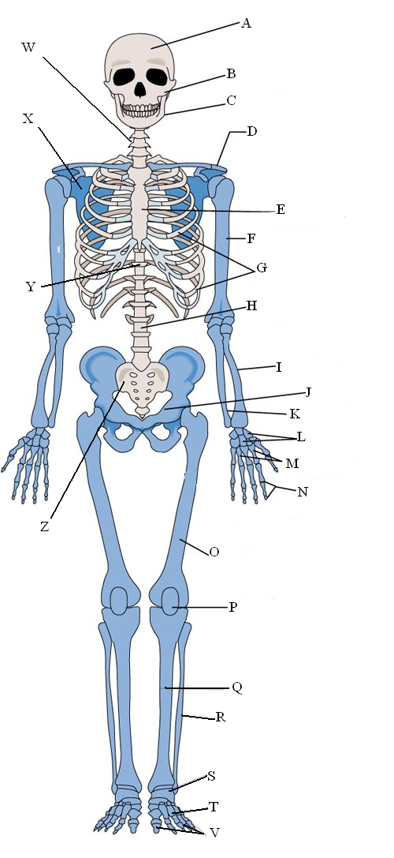
_____ 26. MAXILLA
_____ 27. SCAPULA
_____ 28. STERNUM
_____ 29. HUMERUS
_____ 30. THORACIC VERTEBRAE
_____ 31. RIBS
_____ 32. PELVIS
_____ 33. METACARPALS
_____ 34. ULNA
_____ 35. TARSALS
_____ 36. CERVICAL VERTEBRAE
_____ 37. CRANIUM
_____ 38. CARPALS
_____ 39. METATARSALS
_____ 40. LUMBAR VERTEBRAE
_____ 41. RADIUS
_____ 42. FEMUR
_____ 43. SACRUM
_____ 44.CLAVICLE
_____ 45. MANDIBLE
B
X
E
F
Y
G
M
J
K
S
W
A
L
T
H
I
O
Z
D
C
Color in the Axial Skeleton

BONUS: 1 point each
8
7
# of Carpals __________ # of Tarsals:___________
7
12
5
# of Vertebrae each Cervical:____ _______ Thoracic:_________ Lumbar:__________

