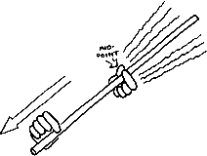

The Singing Rod
Materials:
Crushed Rosin
Singing Rods (various sizes)
Procedure:
1. Firmly hold the center of an aluminum rod horizontally using the thumb and forefinger of one hand.
2. Pinch and release a small amount of crushed rosin with the thumb and forefinger of the other hand.
3. Gently stroke the aluminum rod from the center to the end of the rod using your rosin coated thumb and forefinger. Repeat and slightly increase the pressure of your stroking hand until you hear a high-pitched tone. Too little pressure will not start the vibrations while too much will just hurt!
4. Repeat with other sizes of aluminum rods. Note the difference in pitches based on the size.
Conclusion:
- What size rod made a higher pitch?

- Attempt to hold the aluminum rod at another point (other than in the center) and try to make the noise. Describe what happens.

