Sheep Heart Observation Lab Name(s)_____________________ Date _____ Class __

Purpose:

Procedure A—Observation of a Sheep Heart - External Anatomy
1. Obtain a preserved sheep heart.
2. Place the heart in a dissecting tray with its ventral surface up (See Figure 2 below). Proceed as follows:
Locate the visceral pericardium, which appears as a thin, transparent layer on the surface of the heart. Also
note the abundance of fat along the paths of various blood vessels. This adipose tissue occurs in the loose connective tissue that underlies the visceral pericardium. Identify the following:
right atrium, right ventricle, left atrium, left ventricle, coronary arteries

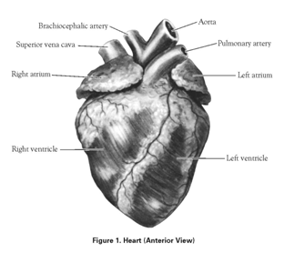

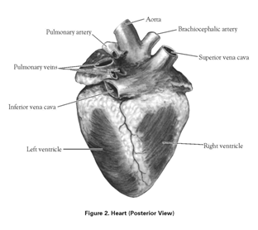
3. Examine the dorsal surface of the heart (Figure 1). Locate the stumps of two relatively thin-walled blood vessels that enter the right atrium. Demonstrate this connection by passing a slender probe through them. The upper vessel is the superior vena cava, and the lower one is the inferior vena cava.

Procedure B—Observation of a Sheep Heart - Internal Anatomy
- Look inside the heart. In the upper left of the right ventricle, notice a flap of tissue made of 3 leaflets. This tissue is connected by a bunch of tendons (The Chordae tendonae or “heart strings” - awww). This is the tricuspid valve. The tricuspid valve sends blood from the right atrium to the right ventricle.
Can blood go backwards from the right ventricle to the right atrium? ___________________
- Find the superior vena cava on the back side of the heart.
- Peek into the right atrium and notice the tricuspid valve (from the other side). Stick your finger into the superior vena cava and through the tricuspid valve.
- Find the aorta. Can you find the aortic valve?
This valve transports blood from the left ventricle into the _________________________.
- Compare the thickness of the walls of the left and right ventricle.
Which one has thicker walls? _____________
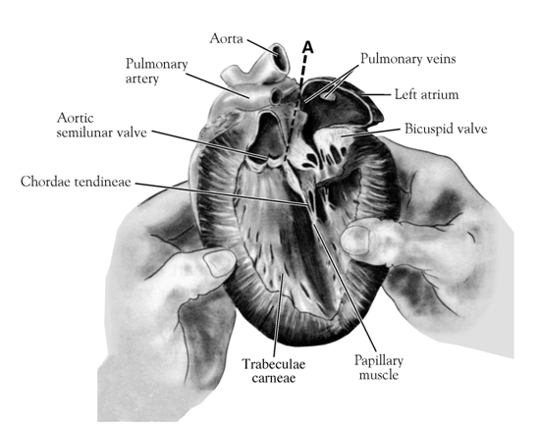

- Measure the thickness of the wall of the right ventricle in cm. __________________
- Measure the thickness of the wall of the left ventricle in cm. ___________________
- At the base of the aorta, look at the aortic valve again.
- Find the mitral valve (bicuspid valve) between the left atrium and the left ventricle. Pass a finger or a probe through it from the left ventricle. Your fingers will be in the left atrium at this point. Try to find the openings of the pulmonary veins which open into the left atrium.

- Once you are confident that you know the structures, clean up your lab station.

*Clean-up. Be sure to dispose of heart in the organic/ green bin. Place used instruments in the clean-up containers.

Analysis and Conclusions

In the picture below, color where the blood should be blue (deoxygenated) and where it should be red (oxygenated). Then fill this in using the blanks to the right. All you have to write is red or blue.
1. ____________________

2. ____________________

3. ____________________

4. ___________________

5. ___red (muscle)______

6. ___________________

7. ___________________

8. ___________________

9. ___________________

10. ___________________
1
2
3
3
4
5
4
6
7
9
8
10

Analysis Questions:

1. How can you tell which side of the heart is the ventral surface?

2. How many chambers are found in the mammalian heart? List these chambers.

3. Which chambers are the pumping chambers of the heart?

4. Which chambers are the receiving chambers of the heart?

5. How do the walls of the atria compare with the walls of the ventricles and why are they different?

6. What is the purpose of heart valves?

7. Name and compare the heart valves found between the upper and lower chambers of the right and left sides of the heart.

8. Vessels that carry blood away from the heart are called _________________, while _________________ carry blood toward the heart.

9. Which artery is the largest and why?

10. What is the purpose of the coronary artery and what results if there is blockage in this vessel?

11. Can an artery carry deoxygenated blood? Explain.

12. Using a flow chart, trace blood flow through the major blood vessels and heart, starting with deoxygenated blood returned from the body (colour code if you would like). Attach another page if necessary.

