Thanksgiving Buffet Animation

- Update the title in slide 1 with your name
Remember to Save Often.
- Go to Slide 2
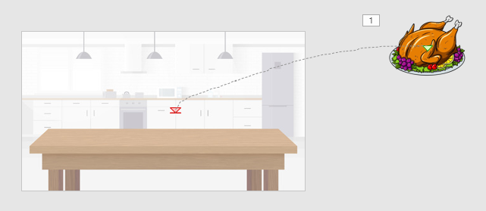

- Change the Zoom of your screen size to 33%
- Insert at least 5 ClipArts of foods/drinks typically served on Thanksgiving
- Put the ClipArts on the sides of the slide like in the picture above
- If necessary make the background of the ClipArt transparent and crop out any unnecessary items.
- Animate each Clipart to fly in from off of the screen onto the buffet table-use a custom path animation for each ClipArt and adjust the time to 5.00
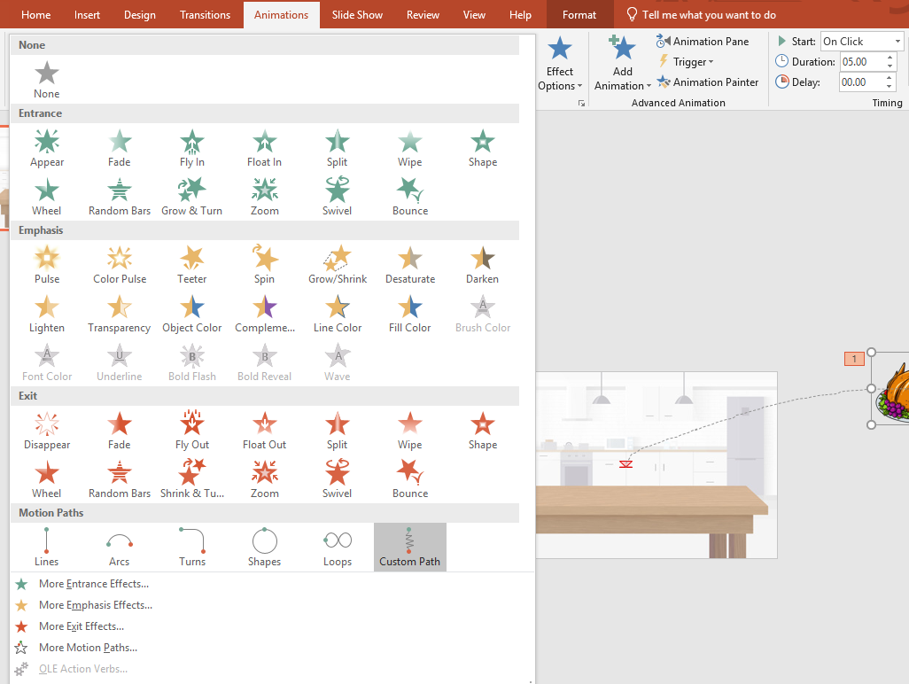
- Use Slideshow view to check all of your animations-make sure all times are sized correctly and placed properly on the table. Make adjustments if necessary.
- Save your work then upload the PowerPoint into Google Classroom.
- Turn in both the assignment and this direction sheet.
