Scrabble Island

Players needed: 4-6 teams, equal number of players on each team
Equipment: 6 hula hoop of different colors, 2-4 swim noodles cut in half, scrabble letter pieces (many)

Space: Gymnasium

Game Set Up (See diagram below): Set up the space as shown below.

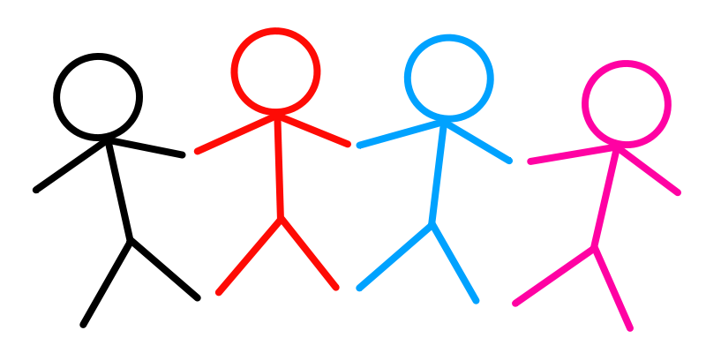



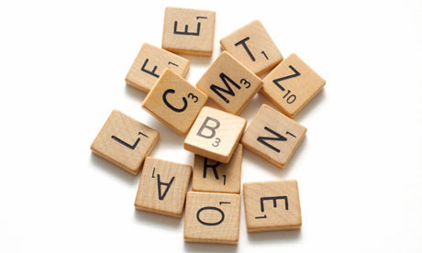

Prep/Advance Planning: I used old thin carpet that I had a school to make my scrabble tiles. Mine are 4-inch x 4 inch squares.

Number of Letters: A Scrabble set contains 9 A’s, 2 B’s, 2 C’s, 4 D’s, 12 E’s, 2 F’s, 3 G’s, 2 H’s, 9 I’s, 1 J, 1 K, 4 L’s, 2 M’s, 6 N’s, 8 O’s, 2 P’s, 1 Q, 6 R’s, 4 S’s, 6 T’s, 4 U’s, 2 V’s, 2 W’s, 1 X, 2 Y’s, 1 Z, and 2 blanks.

Number of Points Per Letter: A-1, B-3, C-3, D-2, E-1, F-4, G-2, H-4, I-1, J-8, K-5, L-1, M-3, N-1, O-1, P-3, Q-10, R-1, S-1, T-1, U-1, V-4, W-4, X-8, Y-4, Z-10.

Object of the game: The object of this is to be the team that creates the most words with the most points.

Rules of the game:
- On the start signal (whistle / go), one player at a time from each team runs out to the objects, picks one up, and returns to their team.
- After tagging the returning player’s hand, the next player leaves.
- If you get tagged before entering the center circle or when leaving the center circle, you turn is over
- Taggers will use a half swim noodle for tagging.
- Play for 3-5 minutes. Give each team a chance to create words. Check words for correct spelling.
- Choose different taggers.

Variations:
- Play for a certain amount of time (2-3 minutes), the team with the most objects wins.
- Change the locomotor movements (skipping, galloping, backwards, etc.)
- Choose the size limit of the words: younger students 2-3 letter words, older students 3-4 letter words
- Allow student with disabilities to adjust the rules (place items on a table, go with a partner, longer noodle, etc.).

