S3 NATURAL MOVEMENT SKILLS TASK CARD 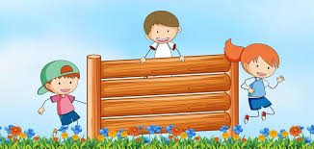
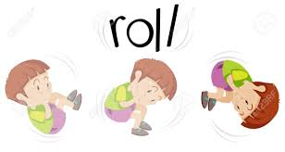

Breathe deeply from the belly 10x | Roll like a log | Balance on 1 body part | Squat like a frog for 2 minutes | Rock while tucked in a ball | Step over something
Leap over lines or objects | Hop on 1 foot then Jump on 2 feet | Skip and Gallop | Roll like a log | Balance on 2 body parts | Go for a walk
Jog without stopping for 2 minutes | Step under something | Climb a tree and hang from the limbs | Crawl like a crab | Carry something heavy and hold it close to the chest, walk with it | Lie flat on the ground on your back with your eyes closed for 2 minutes
Balance on 3 body parts | Crawl under a table | Roll like a ball then stand up | Play Limbo | Crawl with your knees off the ground | Get up and down off the ground for 2 minutes
Look behind you on the left and right sides 20x | Nod your head looking down at your chest 20x | Focus on 3 things you hear for 2 minutes | Focus on 3 things you see for 2 minutes | Hold a push up with your feet touching a wall, now crawl your feet up the wall and stand upside down | Touch your right hand to your left knee while sitting or standing and reverse, alternating taps for 1 minute

