The 100-Meter Dash: Theory and Experiment

Since the completion of the 100-m and 200-m races at the Summer Olympic Games of 1996 in Atlanta there has been a question regarding who is the world's fastest man. Donovan Bailey and Michael Johnson both set world records — Bailey in the 100-m race and Johnson in the 200-m race. The world's fastest man title has traditionally been bestowed upon the runner with the shortest world-record time in the 100-m dash. However, after the 1996 finals, it was publicly remarked that the time obtained by doubling the 9.84 s time for Bailey's 100-m world record to cover 200 m would be greater than that of Johnson's world-record time of 19.32 s in 200 m. This reasoning suggests that Johnson is faster than Bailey.

The Skydome in Toronto held a 150-m race in the summer of 1997 to try and settle the question of who is the world's fastest man. However, the question still remains unanswered
since Johnson suffered a leg injury near the midway point of the race (Bailey was leading at the time).
This note will outline the basic theory and equations describing the position and speed of a human running short sprints, with specific application to the 100-m dash. It will also show how the theory can be applied to the classroom setting. The analysis of the split-time data is made simple by using inexpensive software tools accessible to most classrooms.

Keller's Model of Running
In 1973 Joseph Keller proposed a simple yet effective model of running that can be used to predict the outcome of races between distances of 50 to 10,000 m.¹ According to this theory, the force per unit mass (acceleration) of a runner is given by
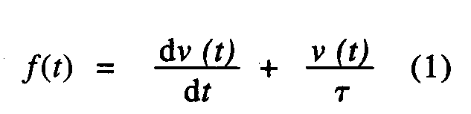
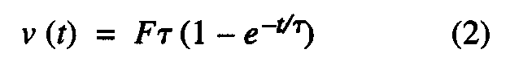
where v is the velocity and t is a time constant associated with the internal resistance of the runner, a quantity that is unique for each runner. For the 100-m dash, the runner is assumed to apply a constant, maximum propulsive force per unit mass, F, throughout the race such that f(t) = F. Using this assumption and integrating (1), the velocity of the runner as a function of time is given by
where the quantity ft is interpreted as the maximum speed of the runner. Upon further integration of (2) the distance traveled in time t is
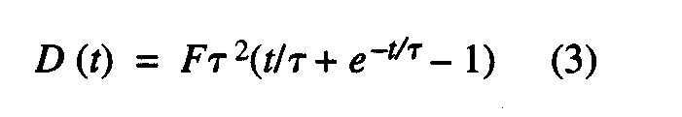

Note that for small time values found near the beginning of the race we can substitute the first three terms of the approximation
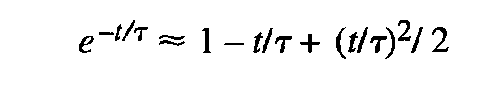
into (3) to obtain the standard formula for position as function of time .
The application of (2) and (3) is only valid for distances less than 290 m. Greater distances require a different approach since the propulsive force per unit mass, F, will be a constant, maximum value throughout the race as the theory requires.

teller Model: Prediction vs Reality
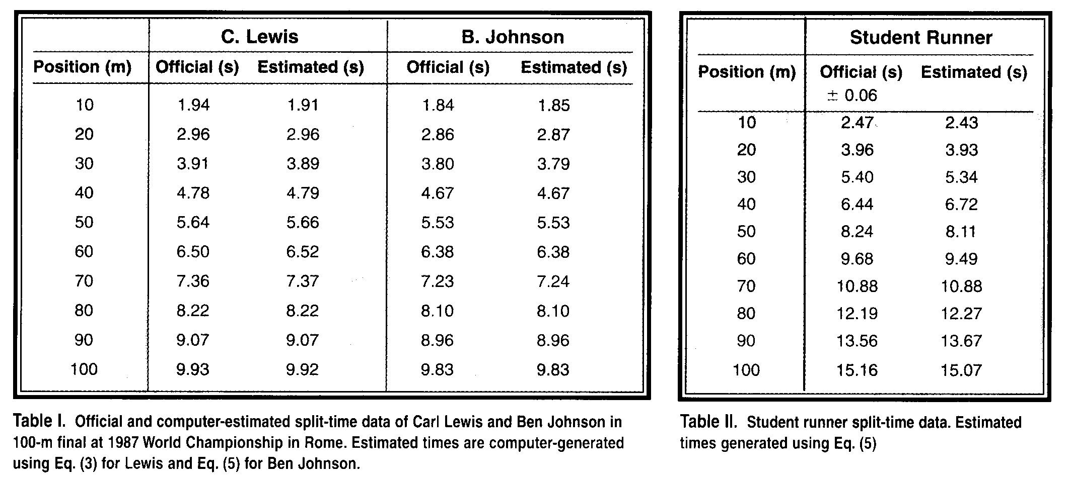
In 1987 two of the world's premiere 100-m sprinters, Carl Lewis and Ben Johnson, raced at the World Championships in Rome ^{2>3} with Ben Johnson winning in world-record time (a time later erased due to steroid use). The split-time data for both men is shown in Table I. Using Graphical Analysis for Windows* we determined the instantaneous velocity for each runner at each 10-m interval. This observation showed that over the last 30 m of the race Lewis is able to maintain a near constant speed while Ben Johnson experienced a noticeable decrease in speed. Equation (3) is applied only to Lewis since he is able to apply a constant maximum force over 100 m. However, a different approach must be taken for Johnson, since the Keller model does not address the problem of decreasing velocity over short distances.

Using Graphical Analysis we fitted the split-time data produced by Lewis to Eq. (3) to determine the constants F and t using the least-squares curve-fitting routine within the program. The generated values of F and t for Lewis are (8.132, 1.452). As a check on the accuracy of the constants F and t, we wrote a simple computer program that uses the values of F and t to calculate the position of the runner at any time in the 100-m race.⁵ The program uses Eq. (3) in a simple loop structure that increments t by Ar = 0.001 s until the calculated value for D = 100 m. Along with the official times, Table I shows the estimated times generated by this program at each 10-m interval for Lewis. The final estimated time (9.92 s) compares well to the official time (9.93 s).
