RUBE GOLDBERG MACHINE
PROJECT---DUE 1/30/18

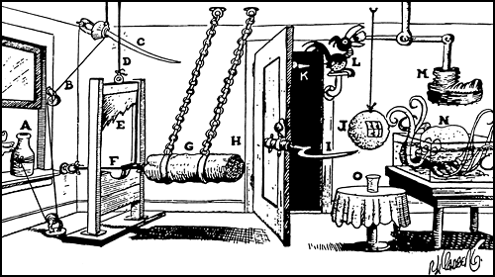

Physics rules the world. Can you use your knowledge of Physics to create a machine to perform a simple task such as taking a whole orange and making a glass of orange juice?

Your task is to create a Rube Goldberg Machine using ideas gathered from research and creativity.

RULES AND REGULATIONS

- The machine must complete the task as described in the challenge.
- The machine must be no larger than 5'H x 6'W x 6'D.
- The machine must have a minimum of 10 steps.
- There are no maximum number of steps.
- No live animals may be used in the machine.
- The machine must not imply profane, indecent or lewd expressions.
- Any loose or flying objects must remain within the set boundaries of the machine. This includes, but is not limited to, drops of water, slivers of balloon, and other “small” objects. Steam and other gasses are exempt from this rule.
- No open flames may be used on the machine.
- No hazardous materials or explosives can be used on the machine.

2018 Rube Goldberg Machine Contest

Team name ___________________________________________________________
(Individuals on team) _____________________________________________________________

Impressions
_____ (20 points.) Two points awarded per step for first 10 steps; 1 bonus point awarded for every 5 extra steps, up to a maximum of 5 bonus points. _____
_____ (10 points) Creative use of unconventional materials
_____ (5 points) Use of creative, uniform theme
_____ (5 points) Number of innovative mechanical steps v. electrical steps

Up and running
First run
_____ (15 points) First run to completion of task
-_____ (NEGATIVE POINTS) Points lost to human interventions, skipped steps. One point lost for 1st touch; 2 points for 2nd touch; 3 points for 3rd touch; 4 points for 4th touch. One point lost for each step skipped during run.

Descriptions
_____ (5 points) Demonstrate knowledge of PE, KE transformations at 5 different steps (labels)
_____ (5 points) Demonstrate knowledge of each of the simple machines (all should be included)
_____ (5 points) Mathematical calculation of PE and KE and Work and Power at ONE point---should have work shown

Spirit
_____ (10 max.) Rube Goldberg spirit.
_____ (-5 max.) Exceeds 9-minute time constraint. Judges have the right to terminate the run once the nine-minute time limit has been exceeded.

Work
_____ (10 points) Used the 2 class days productively and outside class time evident

_____ Grand total (out of 90 points)

