AP Physics – Review Worksheet 1
- Which of the following statements is/are always true for completely elastic collisions?
- System total mechanical energy is not conserved.
- System momentum is conserved.
- The objects stick together.
(a) I (b) II Correct response
(c) I and II (d) I and III (e) I, II, and III
- While rising vertically at 10 m/s, a helicopter passenger fall out the door. Fortunately he has a rope tied to his harness so he can be retrieved. After 2 seconds, how much rope has been pulled out of the helicopter?
(a) 1 m (b) 2 m (c) 10 m (d) 20 m Correct response (e) 30 m
- The drawing shows the path of a projectile that was launched at an angle from the ground. At which points would you find an acceleration of zero, a maximum speed, and a maximum height? (9)
a = 0 v = max height = max
- B E E
- no point C D
- C B C
- no point A C Correct response
- E A C
- If the mass on an oscillating spring is decreased to ½ the original mass: . (41)
- The period will be cut in half, but the frequency will remain the same.
- The period and frequency will remain the same.
- The period will be increased by the square root of two.
- The period will be decreased by a factor of two.
- The Frequency will be increased by a factor of the square root of two. Correct respnse
- What is the best definition of capacitance? (42)
- Capacity to do work.
- How much charge a capacitor can hold.
- How much charge can be stored per volt of potential difference. Correct response
- How large a capacitor is.
- None of the above.
- As shown below, a beam of protons is fired into a magnetic field (B = 1.5 T) at a velocity v = 2.0 x 10⁶ m/s. Find the magnitude and direction of the force on each proton. (52)

- 4.2 x 10⁻¹³ N; out of the page
- 4.2 x 10⁻¹³ N; into the page correct response
- 3.0 x 10⁶ N; into the page
- 4.8 x 10⁻¹⁰ N; into the page
- 4.8 x 10⁻¹⁰ N; out of the page

- A 50.0 g piece of ice at an initial temperature that is unknown is placed into a glass containing 400 g of water 20.0 degrees C. The glass and ice come to thermal equilibrium at 5.0 degrees C. The ice initially floats with 90 percent of its volume under the water surface. (a) What is the density of the ice? (b) What is the buoyant force acting on the ice? As the ice melts assume that no heat is lost. (c) Find the initial temperature of the ice.
(a)

- Consider the pulley apparatus. A box of mass 10 kg is being pulled across a table by a falling box of mass 7.5 kg that is suspended by a cord over a frictionless, massless pulley. The coefficient of kinetic friction between the box and table is 0.20. (a) Find the acceleration of the two-block system. (b) What is the tension in the cord? Now suppose the hanging mass is replaced by a downward force of 75 N. (c) What will be the resulting acceleration of the system? (d) What is the new tension in the cord? (e) How much mass should be added to the first block for it to slide at constant velocity?
(a)
(b)
(c)
(d)
(e)

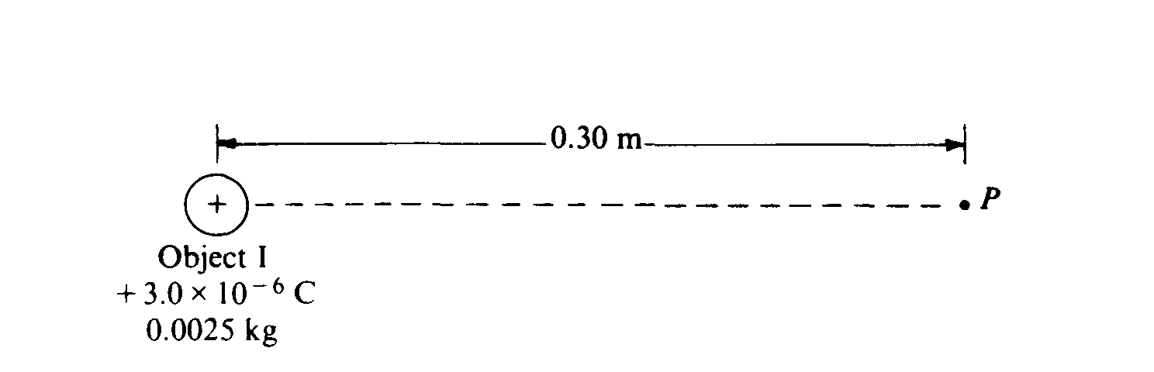
- Object I, shown, has a charge of + 3 x 10⁻⁶ coulomb and a mass of 0.0025 kilogram.
  - What is the electric potential at point P, 0.30 meter from object I?

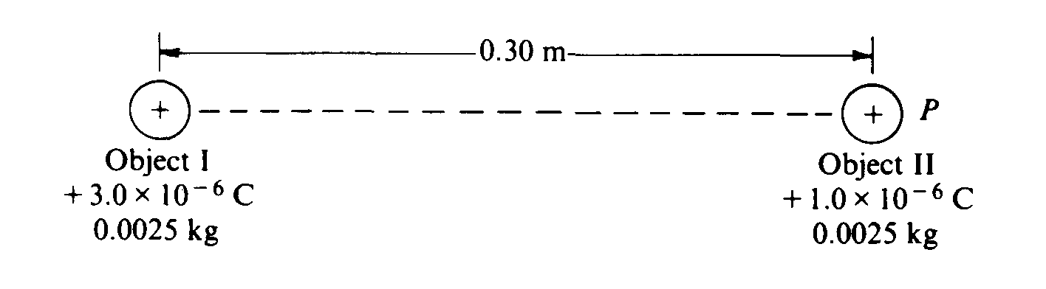
Object II, of the same mass as object I, but having a charge of + 1 x 10⁻⁶ coulomb, is brought from infinity to point P, as shown.
  - How much work must be done to bring the object II from infinity to point P ?
  - What is the magnitude of the electric force between the two objects when they are 0.30 meter apart?
  - What are the magnitude and direction of the electric field at the point midway between the two objects?
The two objects are then released simultaneously and move apart due to the electric force between them. No other forces act on the objects.
to the right, positive
to the left, negative
positive – to right
  - What is the speed of object I when the objects are very far apart?

Stored energy converts into kinetic energy for 2 equal masses

