Name: __________________________________ Pd: ______

Relationship Types Summary

A graph is one of the most effective representations of the relationship between two variables. The independent variable (one controlled by the experimenter) is usually placed on the x-axis. The dependent variable (one that responds to changes in the independent variable) is usually placed on the y-axis. It is important for you to be able to interpret a graphical relationship and
express it in a written statement and by means of an equation.

Graph Shape | Relationship Type | Written Description | General Equation
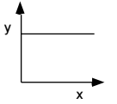
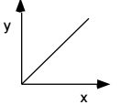
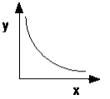
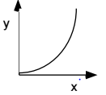
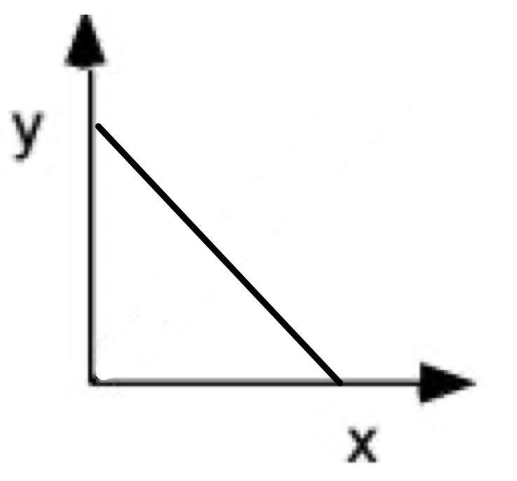
*This is an extension to one of the relationships above

