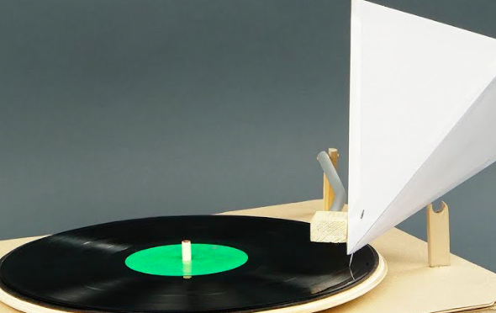
Record Player
Materials:
Record Player
Sewing Needle
Piece of Paper
Various Objects
Record


Procedure:
- Tape the needle to the paper.
- Fold the paper until it resembles a cone.
- Tape the paper so that it stays in the shape of a cone.
- Turn on the record player with record in place.
- Gently place the needle on the record as it turns and listen for music.
- Try using other objects in place of the paper, such as Styrofoam cups, empty 2 liter bottles, cardboard, more than one piece of cardstock, etc.

Conclusion:
- How does a record play music?

- What object made the music the loudest? Why do you think this is true?

