Rate of Molecular Diffusion

FALL SEMESTER 2022
INSTRUCTOR: Mr. Simmons
matthewsimmons@hebisd.edu

Name: _________________________________ Date:_____________
Background Information
Diffusion, which is the subject of this activity, is the movement of molecules or particles from an area of greater concentration to an area of lesser concentration. Diffusion is responsible, in part, for the passage of particles (ions and molecules) into and out of a cell through the cell membrane.
Living cells have a constant need for energy, which is supplied by food molecules that enter the cells from the environment. Cells must also be able to rid themselves of poisonous wastes. If either process stops, the cells die along with the organism of which the cells are a part. Diffusion and active transport are the two main processes that account for the movement of materials into, throughout, and out of cells.
In terms of an experience you may already be familiar with, diffusion takes place when a bottle of perfume is left open. After a while, a person at some distance from the bottle can smell the perfume. The molecules of the perfume travel from the bottle to the person's nose by diffusion. This is an example of gas molecules (the evaporated perfume) diffusing into the space occupied by other gas molecules (the air).
In this experiment you will investigate the rate of diffusion of a liquid in a liquid. You will also investigate how temperature affects the rate of diffusion.
Purpose
To measure the rate of diffusion in a liquid and determine how temperature affects the rate of diffusion.
Procedure
Remember to formulate a hypothesis, or expected explanation, of how temperature affects diffusion before you do the actual experiment.
- With the diagram of concentric circles lying flat on the table, rest a clean petri dish on it so that the petri dish is aligned with the circles.
- Fill a 250 mL beaker half-way with ice water, room temperature water, or hot water.
- Take a temperature reading and record on the chart to nearest degree Celsius (back of this paper).
- Measure approximately 50mL of water from beaker in a graduated cylinder.
- Pour the water into the petri dish.
- One lab partner should begin recording the time (to the nearest second) at the instant the other partner places ONE DROP or PIECE of the diffusing material into the center of the petri dish.
- At 15-second intervals, record the LARGEST distance the material has diffused out from the center on the dish. Remember, this is a running time – once you start the timer, do not stop it until you reach five minutes or the material diffuses to the edge of the petri dish.
  - Remember, the distance between each concentric circle is 5mm.
  - The starting point of the diffusing material is recorded as Time Zero.
- Repeat the above procedure with the remaining two water temperatures.
Ice Water | ºC |  | Warm Water | ºC |  | Hot Water | ºC
Time | Distance |  | Time | Distance |  | Time | Distance
0:00 |  |  | 0:00 |  |  | 0:00
0:15 |  |  | 0:15 |  |  | 0:15
0:30 |  |  | 0:30 |  |  | 0:30
0:45 |  |  | 0:45 |  |  | 0:45
1:00 |  |  | 1:00 |  |  | 1:00
1:15 |  |  | 1:15 |  |  | 1:15
1:30 |  |  | 1:30 |  |  | 1:30
1:45 |  |  | 1:45 |  |  | 1:45
2:00 |  |  | 2:00 |  |  | 2:00
2:15 |  |  | 2:15 |  |  | 2:15
2:30 |  |  | 2:30 |  |  | 2:30
2:45 |  |  | 2:45 |  |  | 2:45
3:00 |  |  | 3:00 |  |  | 3:00
3:15 |  |  | 3:15 |  |  | 3:15
3:30 |  |  | 3:30 |  |  | 3:30
3:45 |  |  | 3:45 |  |  | 3:45
4:00 |  |  | 4:00 |  |  | 4:00
4:15 |  |  | 4:15 |  |  | 4:15
4:30 |  |  | 4:30 |  |  | 4:30
4:45 |  |  | 4:45 |  |  | 4:45
5:00 |  |  | 5:00 |  |  | 5:00

Your lab report should include 5 parts:
- An introductory section containing background information about molecular movement and diffusion.
  - define diffusion
  - explain how molecular movement affects diffusion
  - hypothesis
- Tables containing raw data collected.
- COMPLETE & ACCURATE graph of data
- Conclusion
  - Was your hypothesis supported or disproven? How did temperature affect the diffusion rate?
  - What do you believe were the three largest sources of error in your investigation?
  - What are two ways to improve this lab?
  - Remember to HyDE
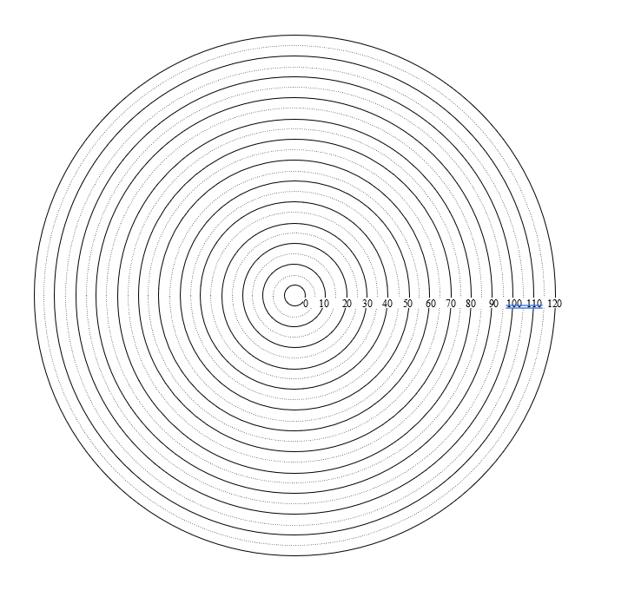
EXTRA CREDIT
Explain WHY temperature affects the rate of molecular diffusion. HINT: What is the definition of temperature?

Remember: A Graph T.A.L.K.S. to You – Title / Label / Axis / Key / Scale

