AP Physics – Try Projo One More Time Quiz

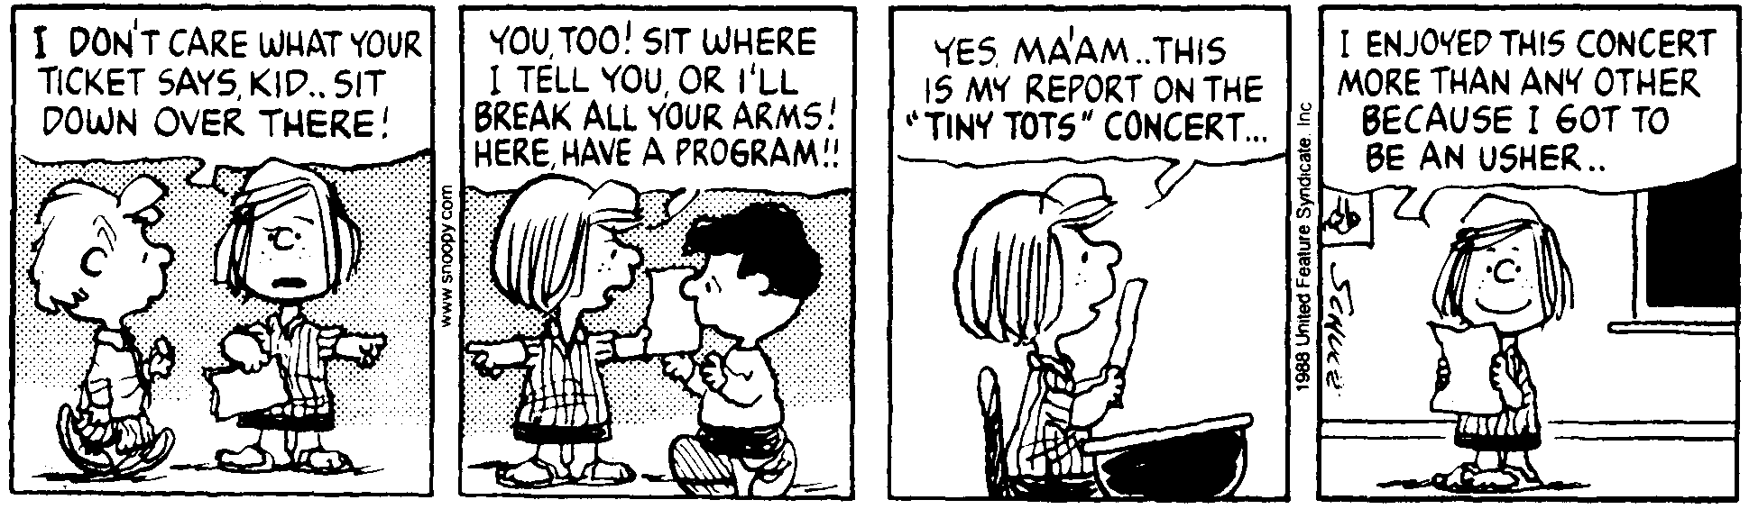
Name ______________________________________________________________________Per__

I like to see a man proud of the place in which he lives. I like to see a man live so that his place
will be proud of him. -- Abraham Lincoln
- A ball rolls across a table at a constant speed for 0.62 m. It then falls onto the floor. It takes the ball 0.35 s to cover the 0.62 m. The path of the ball is shown in the drawing. The tabletop is 1.2 m above the floor. Find x, the distance that the ball travels horizontally after it leaves the tabletop.

- A ship fires a projectile with an initial velocity of 556 m/s at an angle of 41.0° to the horizon. Find (a) the time of flight and (b) the range of the projectile.

- A 5 inch projectile is fired at an angle of 35.0° to the horizontal. If the thing travels a distance of 26 500 m in 102 s, what was the projectile’s initial velocity?

- A car is traveling down the road at a constant speed of 35 km/h. At time zero it is forced to stop. The driver slams on the brakes and the car travels 18 m as it uniformly accelerates, coming to a stop. The car remains at rest for 5.0 seconds. Then the driver shifts into reverse and begins to back up. It accelerates from rest to a speed of 6.0 m/s in 4.0 seconds. The car then travels at this speed for 5.0 seconds. (a) Make a velocity vs time graph for the car’s motion. (b) At the end of all this motion, what is the car’s position?

