AP Physics – Work/Energy Quiz

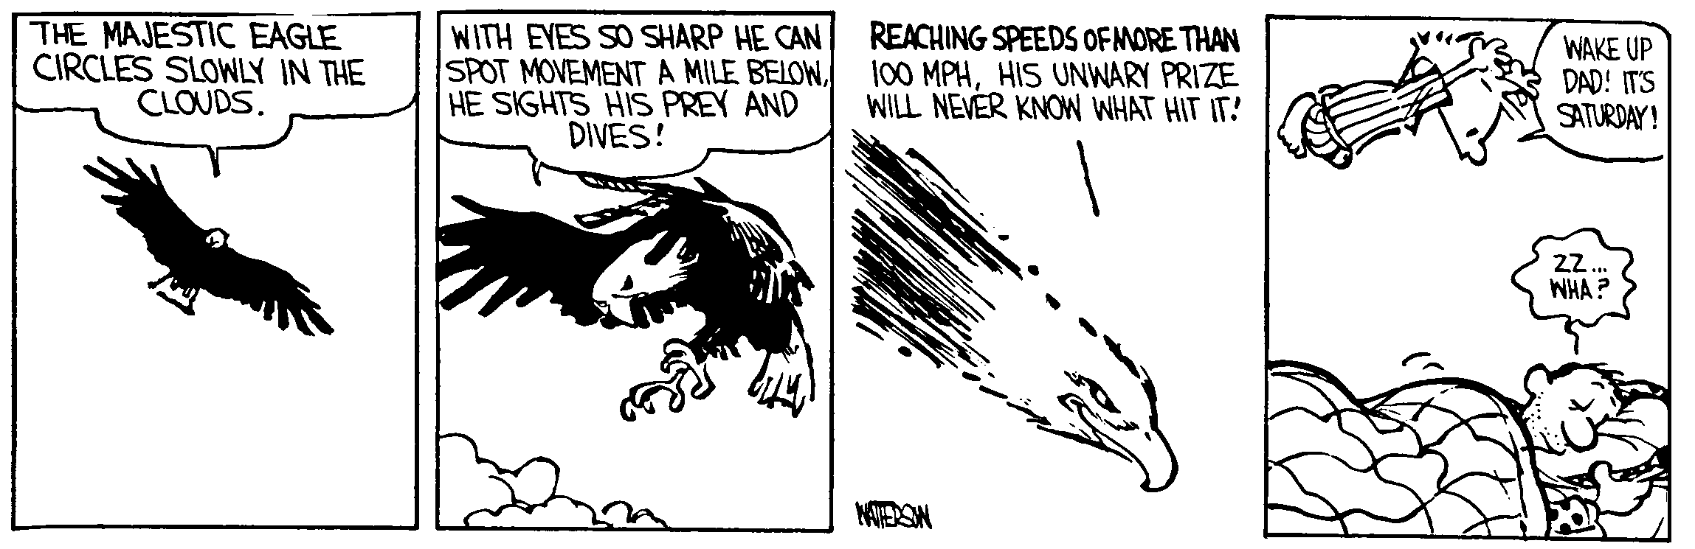
ID, Sir or Ma’am ________________________________________________________________Per___
Research is what I'm doing when I don't know what I'm doing. -- Wernher von Braun
- A 78.2 g wooden block is set up against a spring on a very smooth table. The block is pushed into the spring, compressing it a distance of 5.55 cm and then released. The spring constant is k = 198 N/m. (a) What is the speed of the block when it reaches its initial position (where the spring was not compressed)? (b) If the tabletop is 95.0 cm above the deck, how far from the table edge does the block travel before it strikes the deck? (c) What is the total energy of the block just before it hits the deck?

- A roller coaster starts at some height that you do not know. It goes down this hill and then goes up a second hill that is at a height of 28.5 m at a speed of 15.8 m/s. So how high was the initial hill?

- Two 10-kilogram boxes are connected by a massless string that passes over a massless frictionless pulley as shown. The boxes remain at rest, with the one on the right hanging vertically and the one on the left 2.0 meters from the bottom of an inclined plane that makes an angle of 60.0° with the horizontal. The coefficients of kinetic friction and static friction between the left-hand box and the plane are 0.15 and 0.30, respectively.
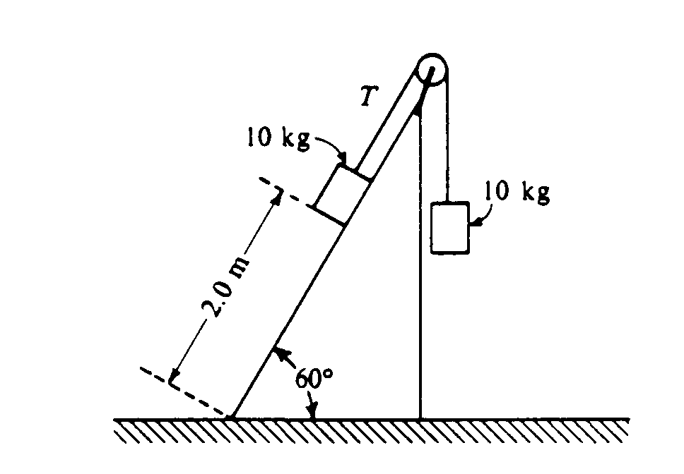
- What is the tension T in the string?

b. On the diagram below, draw and label all the forces acting on the box that is on the plane.
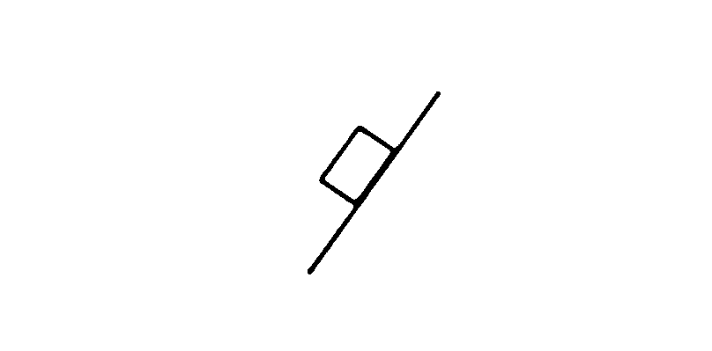c. Determine the magnitude of the frictional force acting on the box on the plane.

The string is then cut and the left-hand box slides down the inclined plane.
d. Determine the amount of mechanical energy that is converted into thermal energy during the slide to the bottom. (This is the work done by friction).
e. Determine the kinetic energy of the left-hand box when it reaches the bottom of the plane.

