AP Physics – Projo Quizo

Phlegm ___________________________________________________________________ Per___
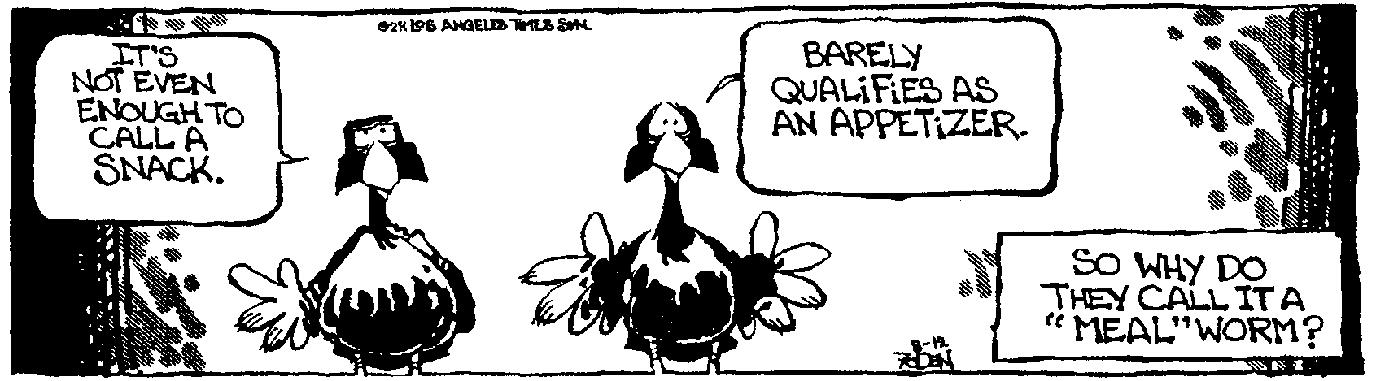
To succeed in the world it is not enough to be stupid. You must also be well mannered. -- Voltaire
- A ball is kicked towards a fence from a point 32.0 m away. The velocity of the ball as it leaves the kicker’s foot is 20.0 m/s at an angle of 37.0° with the horizontal. The top of the fence is 2.50 m. Air resistance is negligible. Find:

- The time it takes for the ball to reach the plane of the fence.
- Will the ball hit the fence? If so, how far from the top of the fence will it hit? If not, how far above the fence will it pass?

- The mighty USS Herpes, a fine pocket battleship, fires off a round that travels a horizontal distance of 33.0 km. The projectile has a time of flight of 1 min and 45 s. Find the elevation angle for the gun.

- A ball rolls across a table at a constant speed for 0.62 m. It then falls onto the floor. It takes the ball 0.35 s to cover the 0.62 m. The path of the ball is shown in the drawing. The tabletop is 1.2 m above the floor. Find x, the distance that the ball travels horizontally after it leaves the tabletop.

- A

