AP Physics – Torque Quiz

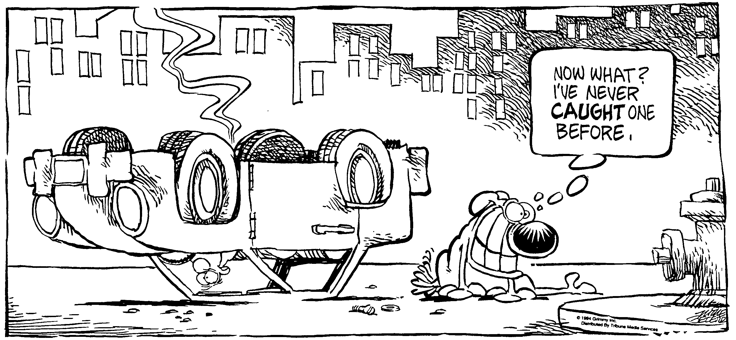
Prudence __________________________________________________________________Per___

He was the wise fellow that being asked what he would of the king, desired he might
know none of his secrets. -- Shakespeare
- A uniform semicircular sign 1.00 m in diameter and a weight of 325 N is supported by two wires. What is the tension in each of wires supporting the sign?

- A 0.00650 kg coin rests on a turntable that rotates at a constant rate. It is 12.5 cm from the center of the thing. (a) Find the linear speed of the coin if the time for one revolution is 1.25 s. The rate of rotation of the disk is gradually increased. The coefficient of static friction between the coin and the disk is 0.350. (b) Determine the linear speed of the coin when it just begins to slip.

- A hungry 700.0 N bear walks out on a uniform beam in an attempt to retrieve some goodies hanging in a bag off the end. The beam weighs 200.0 N and is 6.00 m long and is supported at one end as shown by a beam that is supported at the wall by a hinge; the goodies weigh 80.0 N. (a) Draw a free body diagram for the beam. (b) When the bear is at x = 1.00 m, find the tension in the wire and the components of the reaction force at the hinge. (c) If the wire can withstand a maximum tension of 900.0 N, what is the maximum distance the bear can walk before the wire breaks?

- A young boy pushes on a stick, it is held horizontally and pushes a 15.0 kg ball to the side as shown below. What is the force that the boy must apply to displace the ball as shown?

