AP Physics – Quiz

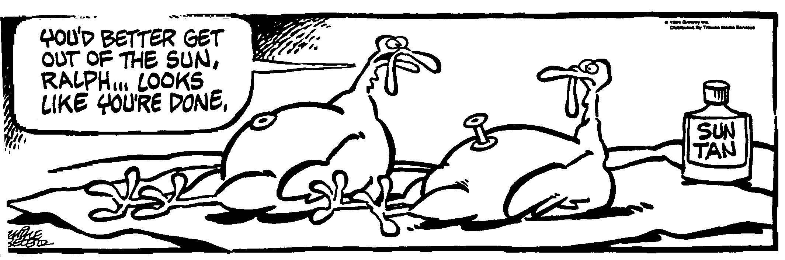
Dum de Dum____________________________________________________________________Per___
The topic for today is quantum physics. Quantum physics was developed in the 1930's, as a result of
a bet between Albert Einstein and Niels Bohr, to see who could come up with the most
ridiculous theory and still have it published. Most people agree that Bohr won hands down,
although Einstein did very well in the swimsuit competition. -- Anonymous
- An atom absorbs light of wavelength 415 nm. Two of the spectral lines given off have wavelengths of 415 nm and 525 nm. (a) Determine the energy levels involved and draw them onto the energy diagram. (b) The ground state for the atom is –7.20 eV. What other wavelengths of light could be given off?

- In a certain metal, the stopping potential is found to be 4.00 V. When 235 nm light is incident on the metal, electrons are emitted. (a) What is the maximum kinetic energy given to the electrons? (b) What is the work function of the metal?

- Beryllium – 9 has a mass of 9.012 174 u. The mass of a proton is 1.007 825 u and the mass of a neutron is 1.008 665 u. (a) Find the mass defect for Be-9 in kilograms, (b) the binding energy for Be-9 in MeV and Joules.

