AP Physics – First Quiz


Glame ___________________________________________________________________Per___
A new idea is delicate. It can be killed by a sneer or a yawn; it can be stabbed to death by a
joke, or worried to death by a frown on the right person's brow. -- Charles Brower
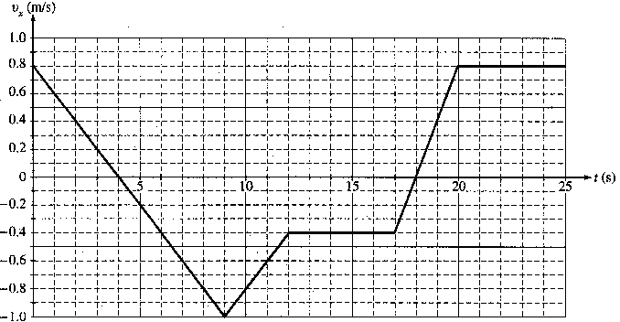
1. A 0.50 kg cart moves on a straight horizontal track. The graph of velocity v_{x} versus time t for the cart is given below.

- Indicate every time t for which the cart is at rest.

(b) Indicate every time interval for which the speed (magnitude of velocity) of the cart is increasing.

- Determine the horizontal position x of the cart at t = 9.0 s.

- A truck undergoes an acceleration of 3.45 m/s² for 12.0 s. It then travels at a constant speed. How many kilometers has it traveled after 45.0 s?

- A leg of lamb is dropped from a bridge that is 22.5 m above the river. (a) how fast is it going when it hits the water? (b) How long does it take it to hit the water?

