AP Physics – Electric Fields Quiz

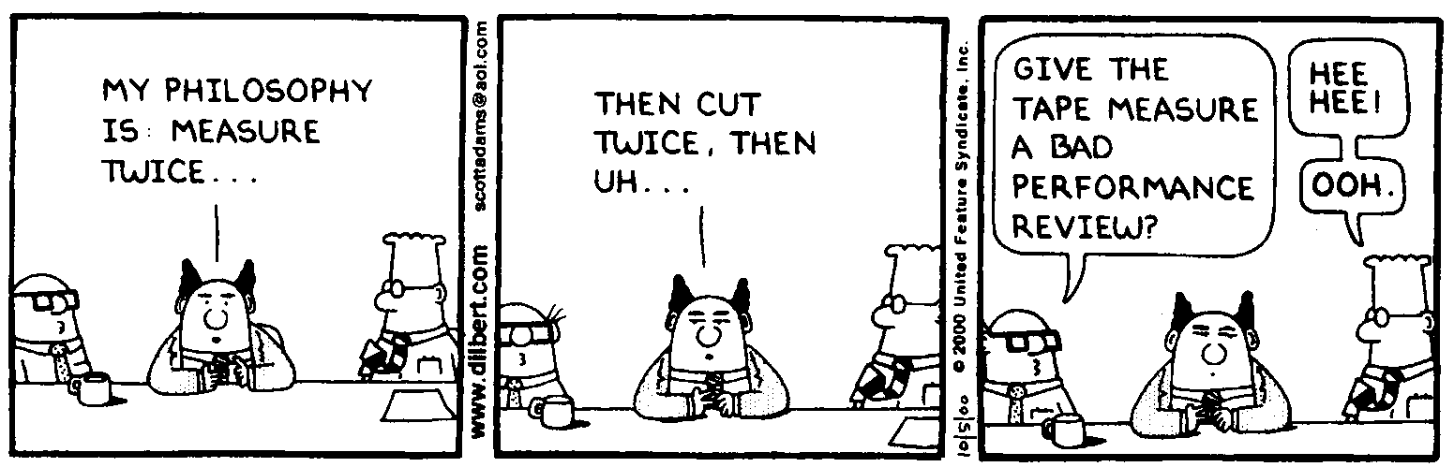
Be it be thee?________________________________________________________________Per__
Whether you think you can or think you can't, then you're right. -- Henry Ford
- What is probably the most significant difference between the electromagnetic force and the gravitational force?

- Find the force between charges of +180.0 μC and -175.0 μC. They are 11.5 cm apart.

- Three charges are arranged as shown. What is the magnitude and direction of the force acting on the -315 μC charge by the other two charges?

- An electron is fired into the midpoint of a field between two charged plates. The initial velocity of the electron is 1.25 x 10⁶ m/s. The plates are a distance of 1.80 mm apart. The ΔV for the plates is 85.0 V. Determine where the electron will hit on the upper plate.

