AP Physics – First Quiz Ans
1. A 0.50 kg cart moves on a straight horizontal track. The graph of velocity V_{x} versus time t for the cart is given below.
- Indicate every time t for which the cart is at rest. 4 s 18 s
(b) Indicate every time interval for which the speed (magnitude of velocity) of the cart is increasing.
4s – 9 s, 18 s – 20 s
- Determine the horizontal position x of the cart at t = 9.0 s.
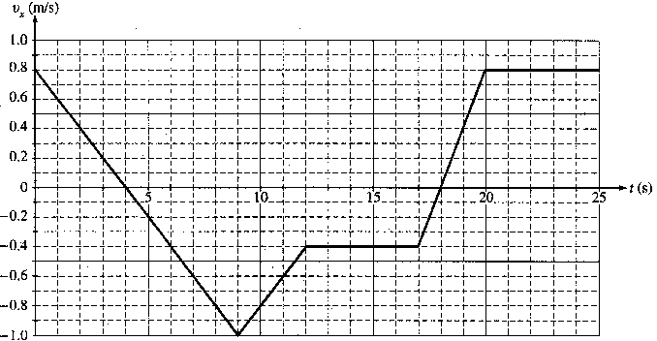

- A truck undergoes an acceleration of 3.45 m/s² for 12.0 s. It then travels at a constant speed. How many kilometers has it traveled after 45.0 s?
- A leg of lamb is dropped from a bridge that is 22.5 m above the river. (a) how fast is it going when it hits the water? (b) how long does it take it to hit the water?

(a)

(b)

