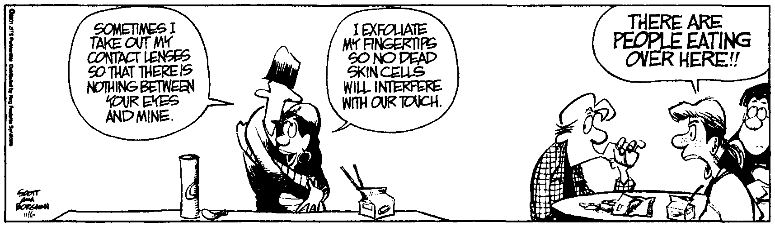
AP Physics – Energetic Momentum Quiz

Who Who?___________________________________________________________________Per___
Nature, to be commanded, must be obeyed. In everything man has accomplished, we have only
manipulated nature into doing what it is. -- Francis Bacon
- A 125 g wooden block is set up against a spring. The block rests on a smooth surface. The block is pushed into the spring, compressing it a distance of 12.0 cm and then released. The spring constant is k = 455 N/m. (a) What is the speed of the block when the spring is totally uncompressed? (b) The block strikes a second block of mass 78.0 g head on, they both undergo an inelastic collision. What is the kinetic energy of the two blocks after the collision? (c) The tabletop is 95.0 cm above the deck. How far horizontally do the blocks travel before they strike the deck?

- A 1.15 kg ball (m₁) moving at 5.00 m/s to the right hits a 2.15 kg ball (m₂) head-on that is traveling at 3.50 m/s to the left. The second ball (m₂) ends up going to the right with a velocity of 0.867 m/s. What is the velocity of the first ball after the collision?

- A ball, m₂ = 1.00 kg, moving at 4.00 m/s collides with another ball, m₁ = 0.750 kg that is at rest. M₂ ends up with a final speed of 0.250 m/s in the opposite direction. All surfaces are smooth.

- What is the speed of the other ball after the collision?

b. The second ball travels up the ramp. How high does it go (find its elevation y)?

- A pocket battleship, the mighty USS Herpes, fires its 16 inch guns at a shore target. A 1360 kg projectile is fired at an angle of 25.0° to the horizontal and is in the air for 48.0 seconds. Ignore the effects or air resistance and assume that the projectile lands at the same elevation as it had when fired. Find: (a) the initial velocity of the projectile, (b) the horizontal distance that the projectile traveled, (c) the kinetic energy of the projectile when it was launched, and (d) the potential energy of the projectile when it is at the highest point in its trajectory.

