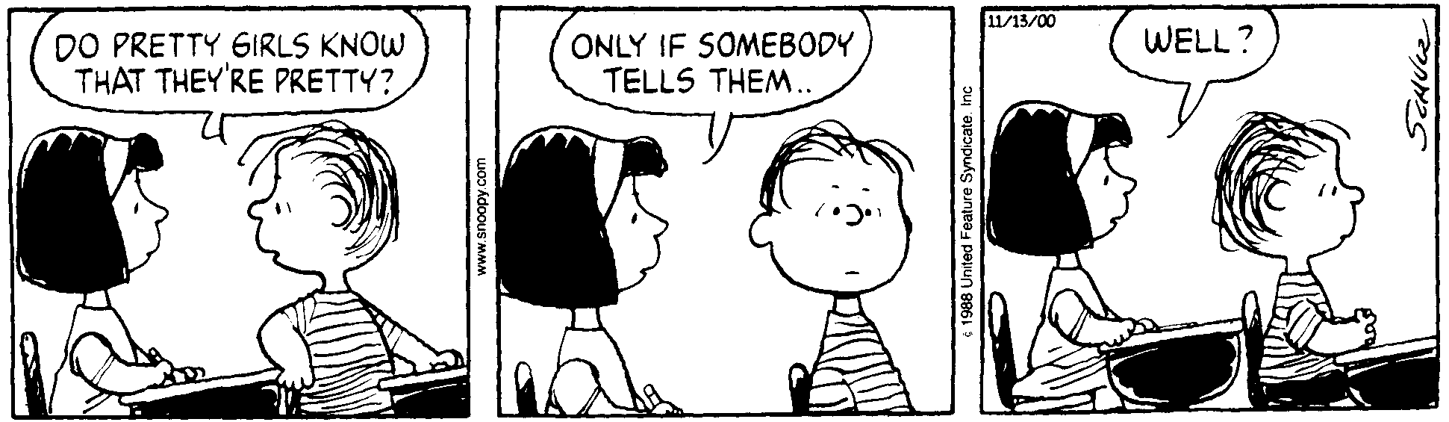
AP Physics – Electric Fields Quiz

Thee Hee?________________________________________________________________________Per__
School days, I believe, are the unhappiest in the whole span of human existence. They are full of dull, unintelligible tasks, new and unpleasant ordinances, brutal violations of common sense and common decency. -- H.L. Mencken
- Two masses are set up as shown. The angle θ that m₁ makes with the vertical is 30.0°. m₁ is 602 g, m₂ is 505 g. m₁ is released, swings down and collides with the other mass. At the point of impact, the string holding up m₁ is vertical and it hits the other ball head on. m₁ ends up with a velocity to the left of 0.150 m/s. Find: (a) the potential energy of m₁ relative to the top of the table, (b) the speed of m₂ after the collision, (c) the distance x that the ball travels before it hits the deck, and (d) the kinetic energy of m₂ just before it hits the deck.

- Three charges are arranged as shown. Find the magnitude and direction of the force acting on q₃ the 955 μC charge by the other two charges?

- A stone is thrown upward and hits the ground 72 m below its starting point. The total time between leaving the thrower’s hand and hitting the ground is 6.0 seconds. (a) What is its initial speed? At some later time the stone is moving down with a speed of 12 m/s, (b) how long a time is this since the stone was thrown? (c) What is the position of the stone relative to the ground? (d) For each of the times below in the table, identify whether the directions of the velocity and acceleration are up, down, or zero.

