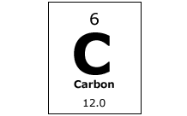
Analyzing Carbon Flow

- Where plants get energy?

- What form do they store energy in?

- What gas do plants release as a by-product of storing the sun’s energy in sugar molecules (photosynthesis)?

- What do animals breathe?

- What do animals breathe out?

- Where do animals get energy from?

- What do humans breathe in?

- What do humans breathe out?

- Where do humans get energy from?

- Where do plants, animals, and humans get the energy they need to live from?

- What impact does the carbon cycles have on climate change?

- Why is it important to use new carbon as opposed to old carbon?

- How can we use less old carbon?

- What are different sources of energy we can use instead of fossil fuels?

- What happens when we run out of fossil fuels?

