Name_______________BOX #__________
DATE______________PER_____
AP Physics B – Projectile motion
Materials: Dart Gun, Black Paper, Meter stick, Chalk

Pre-lab: CONSIDER THE FORMULA BELOW: This is one of three _________________ equations
1. $x=v_{o_{x}}t+\frac{1}{2}{\text{at}}^{2}$
In the box, re-write this equation so that it represents the vertical direction

2. What is the magnitude and direction( just a sign +/- will suffice) of gravity?

3. Is it ever zero, in this direction?

4. Does gravity work horizontally?

5. Is gravity, an acceleration or a force?

6. According to your answer in #4 and #5, the NUMERICAL value for acceleration in the x-direction must be what?

7. Substitute your answer from #6 in the equation below and rewrite the equation in the box provided.
$x=v_{o_{x}}t+\frac{1}{2}{\text{at}}^{2}$

8. According to your answer, once again, in #6: What can you say conceptually about the horizontal velocity?

9. What does the VERTICAL velocity do as the dart approaches the ground?

10. If the dart begins HORIZONTALLY, what do you think the INITIAL VERTICAL VELOCITY is equal to?

11. Out of all the different variables, which one is the same for BOTH the “x” and “y” directions?

12. If 2 equations share an identical variable , what can you do?

13. Take your advice in #12 and show below one formula for a projectile.

14. Notice in your formula the “y” is on one side and “x²” is on the other. Is this true?

15. What is left over if we ignore the “x²” and “y”?

16. If “y” was the rise of a graph and “x²” was the run, this left over part is considered the what?

Purpose: To graphically determine the horizontal velocity of a dart and then use that velocity to predict a range.
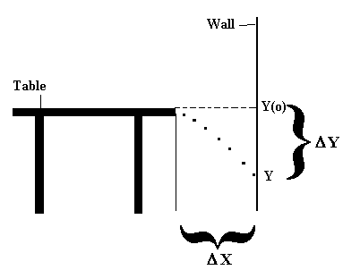
- Place a lab table a certain “x” displacement away from the wall.
- Tape a large sheet of dark colored paper against the wall.
- Mark the Height (Y(o)) of the lab table on the dark paper.
- Measure and record the horizontal displacement away from the wall.

- Shoot a chalk tipped dart horizontally off the edge of the table so that it strikes the paper. You may want to shoot the dart more than once at this setting for accuracy.

- Measure and record the vertical displacement from where the dart hit to the top of the table mark.

- Repeat this procedure using five other horizontal displacements.
Trial | Y | X | X²
1
2
3
4
5
6

- Using Graphical Analysis, make a Y vs. X² graph and find the slope.

Slope =________________

Calculations
Using the slope of your graph, set it equal to the part of the equation mentioned in pre-lab #15 and solve for the horizontal velocity of your dart below. Show all work!

Measure and record the complete height of the table below. Using this height and the vertical formula, calculate the amount of time a projectile would be in the air using your gun. Show all work!

Calculate the horizontal displacement of the dart using your time and your calculated horizontal velocity.

Part II
- Shoot the dart horizontally from the table and record the horizontal displacement from the table to the point where it lands. Do this three times to get an average.
Trial | Horizontal Displacement
1
2
3
AVERAGE | =

Calculate a % difference between the calculated displacement and the measured displacement
$$\text{\%}\text{difference}=\frac{\left|\text{Calculated}−\text{Measured}\right|}{\left|\text{Average}\right|}x\text{100}=$$

Describe and explain some types of experimental error that may have occurred here.

