AP Physics – Problem Solving Explanation Deal

There’s a problem below – a really good one (it’s from one of the AP Tests).

The Physics Kahuna wants you to do this:

- Don’t solve the problem.
- Instead, write out in detail how you would solve each of the questions – what you would have to do, what equations you would use, what you would have to look up, what you would have to calculate. Don’t leave out any steps and explain what is going on.
- The Physics Kahuna wants to see a road map showing how the problem should be solved.

- 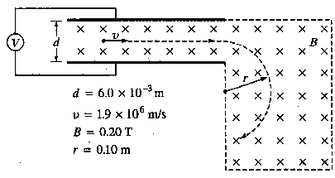A particle with unknown mass and charge moves with constant speed V = 1.9 x 10⁶ m/s as it passes undeflected through a pair of parallel plates, as shown above. The plates are separated by a distance d = 6.0 x 10⁻³ m, and a constant potential difference V is maintained between them. A uniform magnetic field of magnitude B = 0.20 T directed into the page exists both between the plates and in a region to the right of them as shown. After the particle passes into the region to the right of the plates where only the magnetic field exists, its trajectory is circular with radius r = 0.10 m.

(a) What is the sign of the charge of the particle? Check the appropriate space below. Justify your answer.

___Positive ___ Negative ___ Neutral ___It cannot be determined from this information.

- On the diagram below, clearly indicate the direction of the electric field between the plates.

- Determine the magnitude of the potential difference V between the plates.

(d) Determine the ratio of the charge to the mass ( q/m) of the particle.

