Calculating Your Carbon Footprint NAME___________________________
Estimate your carbon footprint using the carbon footprint calculator provided by The Nature Conservancy at http://www.nature.org/greenliving/carboncalculator/. Choose the number of people in your household and select ‘For Me Only’ in the blue ‘Get Started’ tab. If a prompt appears, click OK to proceed.

- Answer the questions in the Home Energy, Driving & Flying, Food & Diet, and Recycling & Waste tabs. Calculate your carbon footprint in tons of CO₂ eq/year and write the value below:

- Which of the tabs/categories represents your largest contribution of carbon?

- Where can you reduce your carbon input the most? Name the category and a specific action or strategy you can take.

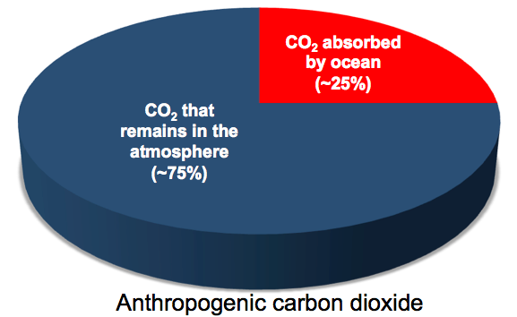
Carbon dioxide (CO₂) can remain in the atmosphere for hundreds to thousands of years once it is released into the atmosphere. It has been estimated that 20-30% of human CO₂ emissions is absorbed by the world’s oceans.

- Calculate (in tons of CO₂ eq/year) how much of your carbon contribution is absorbed by the ocean, assuming 25% of the carbon you contribute to the atmosphere is absorbed by the ocean.

- Carbon dioxide is a greenhouse gas that, when in the atmosphere, can increase Earth’s average temperature. How might recent climate change be different if the Earth’s ocean didn’t absorb CO₂?

During the next class we will discuss what happens to carbon dioxide after it is absorbed by the ocean and some of the negative aspects of this process.

