Position–Match Graph
Kinematics: position versus time, linear motion, graphing | GLX setup file: position match

Purpose

The purpose of this activity is to explore graphs of motion (position versus time). Use a Motion Sensor to measure your motion as you move back-and-forth at different speeds. The challenge is to move in such a way that a plot of your motion will ‘match’ the position versus time graph that is provided for you.

Background
A sonar ranging device such as the Motion Sensor uses pulses of ultrasound that reflect from an object to determine the position of the object. As the object moves, the change in its position is measured many times each second. The change in position from moment to moment is expressed as a velocity (meters per second). The change in velocity from moment to moment is expressed as an acceleration (meters per second per second).
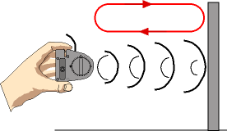
The position of an object at a particular time can be plotted on a graph.

Fig. 1: Motion Sensor
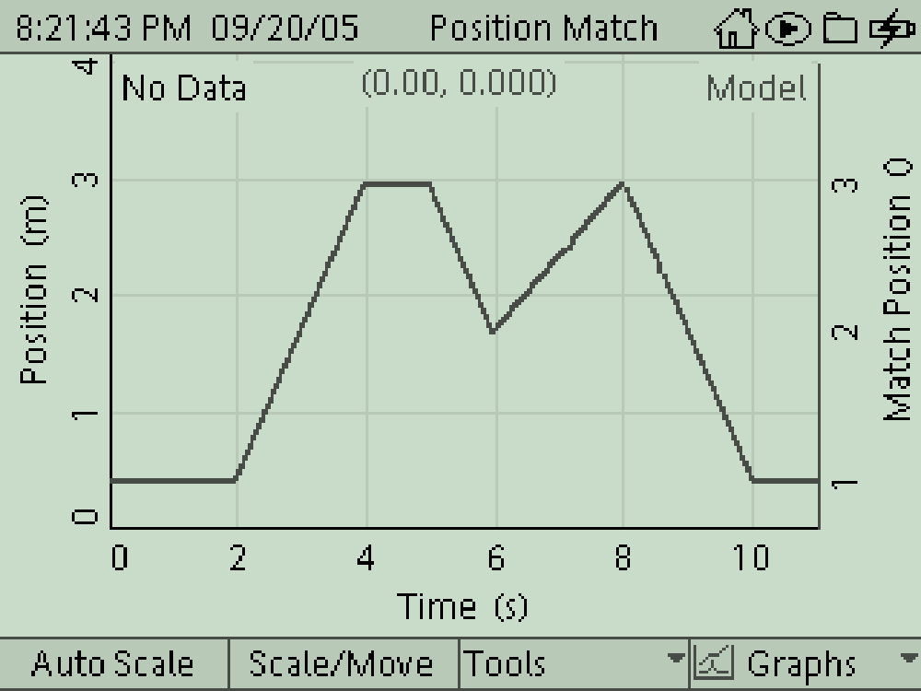
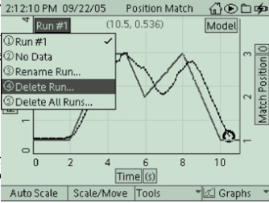

Fig. 2: position match file

Procedure
- Connect the Motion Sensor to one of the sensor ports.
- Turn on the Dataquest and open the file labeled position match
- The setup file has a ‘target’ graph of Position (m) versus Time (s) for you to match.
- Move the range selection switch at the top of the Motion Sensor to the ‘far’ (person) setting.
- Turn the Motion Sensor so it faces at you.

Record Data
- Observe the Graph on the Dataquest. Press Start () to begin recording data.
- Move back-and-forth in order to match the position-time graph. Repeat several times until you are close to matching the graph. Switch to a new graph once you have mastered the first.

Lab Report - Activity 1: Position–Match Graph

Name ________________________________ Date ___________

Questions
- What happened on the graph as you move away from the Motion Sensor? (Draw a sketch of how the graph looked.)

- What happened on the graph as you move towards the Motion Sensor? (Draw a sketch of how the graph looked.)

- How well did your motion graph match the provided graph. Who was the best in your group and why?

- What was the meaning of the part of the position plot where the slope was positive (upward)? If the curve was very steep, what did that mean?

- Were certain parts of the plots easier to match than other parts? Why or why not?

