Polyurethane Foam Hands
Preparation of Polymers

Introduction
Try this amazing demonstration! Simply mix two liquids together and watch as the mixture expands to about 30 times its
original volume. The result is a hardened, lightweight polyurethane foam.

Discussion
There are many forms of polyurethane such as fibers, coatings, elastomers, flexible foams, and rigid foams. The foam in this system is a rigid foam that is used in furniture, packaging, insulation, flotation devices, and many other items. Here, a rigid polyurethane foam is produced by mixing equal parts of two liquids, called Part A and Part B. This lightweight foam expands to about thirty times its original liquid volume and will become rigid in about five minutes.

Part A is a viscous cream-colored liquid containing a polyether polyol, a silicone surfactant, and a catalyst. The polyether polyol may be a substance such as polypropylene glycol [HO(C3H6O)nH]. The hydroxyl (–OH) end of the polymer is the reactive site. The silicone surfactant reduces the surface tension between the liquids. The catalyst is a tertiary amine that aids in speeding up the reaction without being chemically changed itself.

Part B is a dark brown viscous liquid containing diphenylmethane diisocyanate [(C6H5)2C(NCO)2] and higher oligomers (dimers, trimers or tetramers) of diisocyanate. When the polyether polyol (Part A) is mixed with the diisocyanate (Part B), an exothermic polymerization reaction occurs, producing polyurethane (see Equation 1).
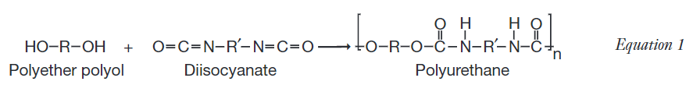
During the course of the polymerization reaction, a small amount of water reacts with some of the diisocyanate. A
decomposition reaction occurs and produces carbon dioxide gas, thus causing the solution to foam and expand in volume. Pores in the mixture are created from the gas; these pores are visible when looking at the rigid substance. The multifunctionality of both reactants leads to a high degree of crosslinking in the polymer, causing it to become rigid within minutes. (See Equation 2.)
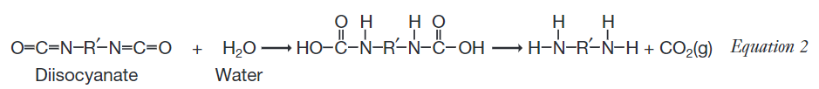

Materials
Polyurethane Foam System (Part A and Part B)
Food coloring (optional)
Acetone (optional)
Paper towels or newspaper
Disposable cups (clear plastic, if available), 2
Tongue depressor or stirring rod
Disposable glove, XL or L

Safety Precautions
This activity should only be performed in a fume hood or well ventilated area. Avoid breathing any vapors produced and avoid skin contact, as both Part A and Part B may contain skin and tissue irritants. Wear chemical splash goggles, chemical-resistant gloves, and a chemical-resistant apron. Please review current Material Safety Data Sheets for additional safety, handling, and disposal information.

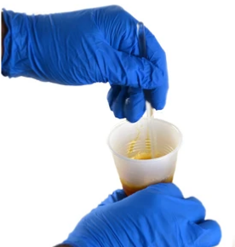
Procedure
- In a fume hood or well ventilated area, pour approximately 30 mL of liquid Part A in a disposable cup. Note: The exact
- volume is not critical. Do not use glassware! It is almost impossible to remove the hardened foam. Please use only disposable materials for the handling and mixing of the chemicals.
- Place approximately 30 mL of liquid Part B in a second disposable cup. Note: The volume of Part B should be approximately equal to that of Part A.
- If desired, add several drops of food coloring to one of the cups and stir thoroughly to mix.
- Spread paper towel or newspaper layers flat on the table and place one of the cups in the center of the paper towel.
- Pour the contents from the second cup into the cup on the paper towel and stir thoroughly.
- While one partner holds open the L or XL glove, pour the mixture into the glove. Make sure to get it into all of the fingers. Watch that foam does not come out of the top! If you start to have spillage, make sure it is into a garbage can or onto the paper towel layers!
- Hold/shape the glove until the polymer is hardened (4-5 minutes).
- Observe the foam as it expands to about 30 times its original volume. The glove will get warm, indicating an exothermic reaction. Do not touch the foam until it is completely hardened.

Disposal
The disposable cups may be thrown in the trash. Any leftover liquids should be mixed together, allowed to react, and then
the solidified polymer may be disposed of in the trash according to Flinn Suggested Disposal Method #26a. Please consult
your current Flinn Scientific Catalog/Reference Manual for proper disposal procedures.

