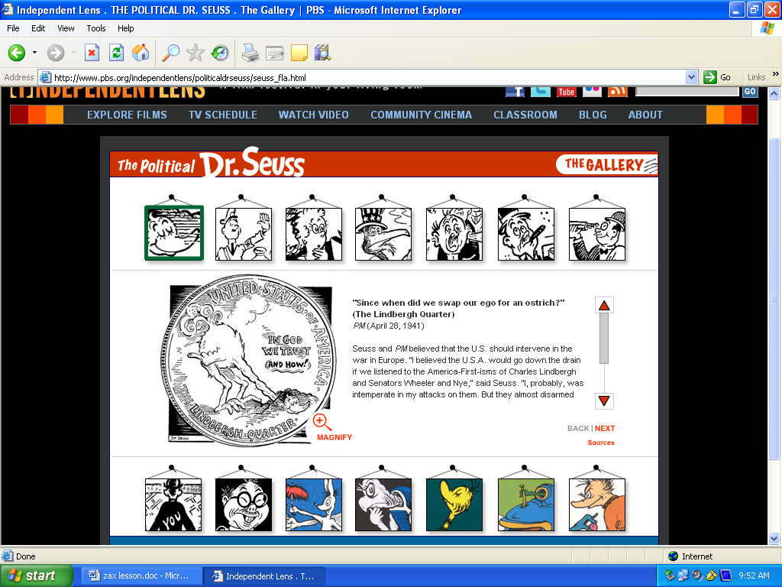

Task A:
1. What are some advantages of political cartoons over plain text articles?

2. What are some of the purposes and outcomes of political cartoons?

Task B: Log onto www.Dictionary.com and define the following terms
1. | Fascism: | ____________________________________________________________
2. | Anti-Semitism | ____________________________________________________________
3. | America First Movement | ____________________________________________________________
4. | Japanese American Internment | ____________________________________________________________
5. | Left-wing | ____________________________________________________________
Task C: Log onto http://www.pbs.org/independentlens/politicaldrseuss/gallery.html
Read the introduction on the page and then click Enter Gallery.
Examine each of the black and white political cartoons Read the titles and captions for each image. Complete the chart below that describes the title, topic and views of Dr. Seuss
 | Cartoon Title | Topic | Dr. Seuss's view
 | Write the name of the cartoon | Write the historical event or situation the cartoon addresses. Example: the America First movement during World War II | Write the viewpoint Dr. Seuss takes in this cartoon. What is he trying to say in his drawing?
1.
2.
3.
4.
5.
6.
7.
8.
9.
10.
11.
12.
13.
14.
Task D: Log onto Regents prep.Org and click the multiple choice questions link. On the interactive side click 6a. World War Two. Complete multiple choice questions online: 3, 5, 7, 12, 21, 24, 31, 32, 35, 36, 40, 41, 47, 50, 53, 62, 70, 71

Student Name: Period _____

Cartoon Analysis Worksheet

Name of Newspaper/Website:
Level 1
Visuals | Words (not all cartoons include words)
- List the objects or people you see in the cartoon. | - Identify the cartoon caption and/or title
 | - Locate three words or phrases used by the cartoonist to identify objects or people within the cartoon.
 | - Record any important dates or numbers that appear in the cartoon.
Level 2
- Which of the objects on your list are symbols? | - Which words or phrases in the cartoon appear to be the most significant? Why do you think so?
- What do you think each symbol means? | - List adjectives that describe the emotions portrayed in the cartoon.
Level 3
- Describe the action taking place in the cartoon.

- Explain how the words in the cartoon clarify the symbols.
- Explain the message of the cartoon.
- What special interest groups would agree/disagree with the cartoon's message? Why?

