AP Physics – Heavenly Body Lab

Names ___________________________________________________

___________________________________________________

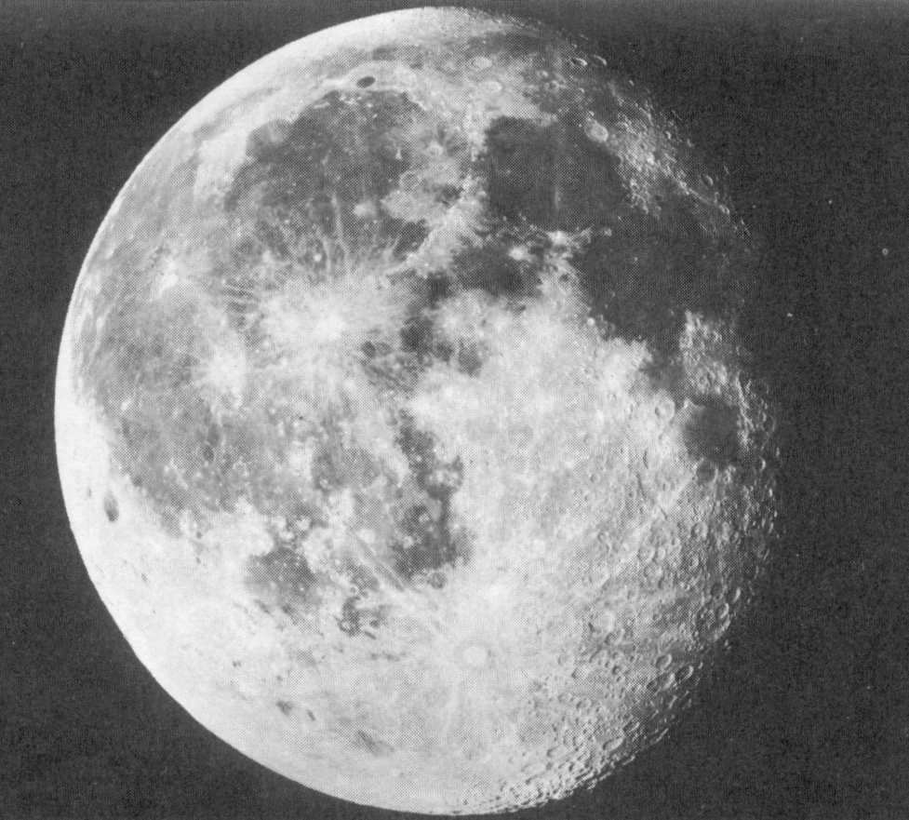
The Physics Kahuna himself has required your group to make certain predictions concerning the size of a certain, designated celestial body, i.e., the earth. Based on a model of the sun. Do no research on this topic, use the knowledge you now possess to make the prediction. You have several spheres to choose from. Pick the one that you think would best represent a scale model of the moon.

Part 1:

- Prediction for size of the moon (describe the sphere, including its diameter in centimeters):

Reasoning behind the prediction:

- Prediction for scale distance between the earth and the moon, using the size of the earth model to establish the scale (in meters please).

Reasoning behind the prediction:

Record these predictions on a large sheet of paper, which you will then post on one of the classroom bulkheads. You will be given the opportunity to share your ideas.

Once all groups have shared their ideas, you are directed to obtain all pertinent data and calculate an accurate scale diameter of the moon and an accurate scale distance separating the moon and the earth. Do the calculations on the back of this sheet. The Physics Kahuna reminds you to properly show your work.

Part 2:

- Size of moon:

Description of scale sphere that best approximates the moon and its diameter (in centimeters):

Work:

- Distance from the earth to the moon calculation:

Actual scale distance (in meters):

Work

