AP Physics – Heavenly Body Lab

Names ___________________________________________________

___________________________________________________

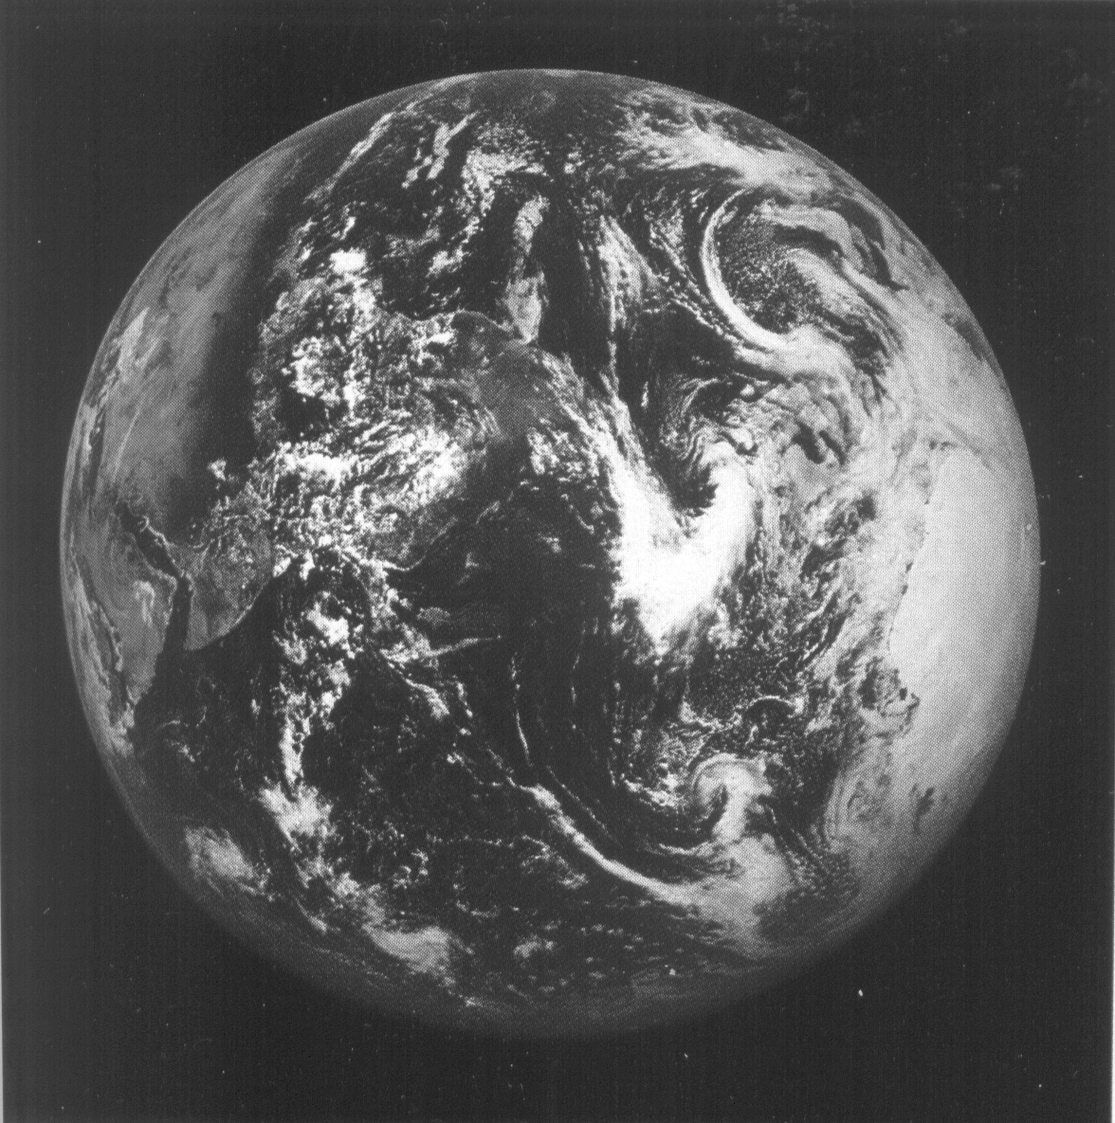
The Physics Kahuna himself has required your group to make certain predictions concerning the size of a certain, designated celestial body, i.e., the earth. Based on a model of the sun. Do no research on this topic, use the knowledge you now possess to make the prediction. You have several spheres to choose from. Pick the one that you think would best represent a scale model of the earth.

Part 1, The Prediction:

- Prediction for size of the earth (describe the sphere you selected, including its diameter in millimeters):

Reasoning behind the prediction:

- Prediction for scale distance between the sun and the earth, using the size of the sun model to establish the scale (in meters please).

Reasoning behind the prediction:

Record these predictions on a large sheet of paper, which you will then post on one of the classroom bulkheads. You will be given the opportunity to share your ideas with the rest of the crew.

Once all groups have shared ideas, you are directed to obtain all pertinent data and calculate an accurate scale diameter of the earth and an accurate scale distance separating the sun and the earth. Do the calculations on the back of this sheet. The Physics Kahuna reminds you to properly show your work.
Part 2:

- Size of earth calculation:

Description of scale sphere that best approximates the earth and its diameter (in millimeters):

Work:

- Distance to sun calculation:

Actual scale distance (in meters):

Work

