RAPIER PLANE DESIGN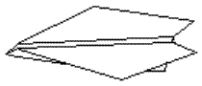
- First take a rectangular (8 1/2" by 11") sheet of paper and fold down the center dotted line; opening it out again afterwards.
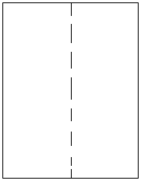
- Take the first 1cm (1/2") of the rectangular sheet and fold it up along the dotted line in
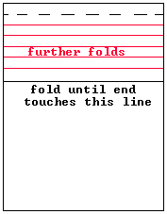
- Fold the flap over and over until about 3/8 of the length of the sheet is folded in this fashion; this should give a heavy and thick front lip.
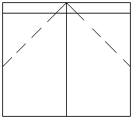
- Now fold along the two dotted lines bringing the top edges into the center line and fold along the center line
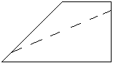
- Fold the wings down along the dotted line; one either side of the center. Now the plane should look like the diagram at the top of the page.

Glider Instructions
- Start with a plain piece of paper and fold it in half
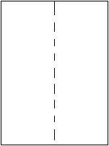
- Then fold down a flap as shown and repeat the process with a flap on the other side to give you
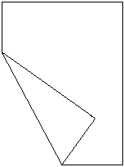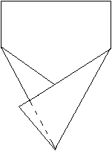
- Now fold over the overhanging flap
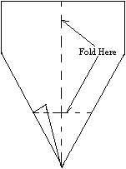
- Then turn the plane over and fold the nose of the plane up
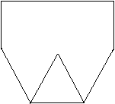
- Crease again along the middle line and then fold along the dotted lines. It is important that the folds at the ends of the wing are folded downwards so you get a plane as at the top of the page otherwise the plane flies upside down.
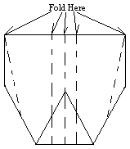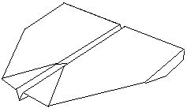
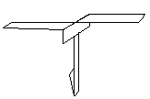  - Cut out the diagram to the right then cut along all the solid lines.  - Fold flap A forward and flap B to the back.  - Fold flaps C and D both forward along the dotted lines.  - Fold along the line E upward to give a weight at the bottom.  - Now this should look like the diagram at the top.  - You just drop the model with the blades facing upwards and the weight at the bottom facing downwards for the best results.  - Measure the height you drop it from and the time it takes to hit the ground to calculate the speed of your helicopter. | 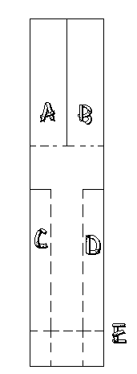
Top of Form

