Pitsco Rockets – Projectile Motion
Equations:
- Vf = Vi + a*t g = -9.8 y = -1/2 g (t²)
Procedure:
- We will use your cell phone to measure the time in the air.
- You must then calculate the velocity and the height (y).

Data Table:

Time in the air = ______________ Time/2 = ________________

Vf = 0 at the top of the path
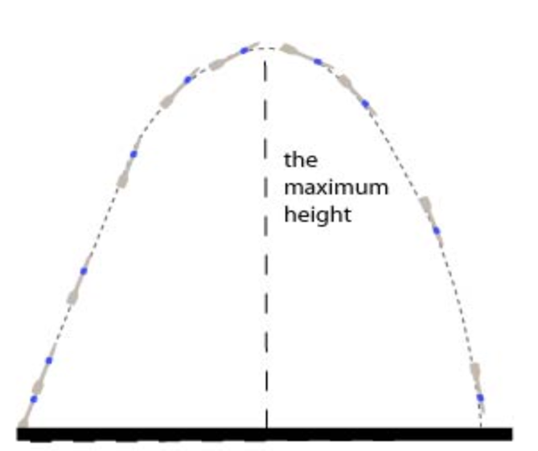
To calculate the time of the projectile to the top of the path divide the time for the entire path by 2.

Total Time / 2 = Time to top of flight

Conclusion:
- Calculate the initial velocity of the rocket:
Vf = Vi + a*t

0 = Vi + (-9.8 * t/2)

Vi = 9.8 * t/2

Vi = _________

- Calculate the height the rocket flew (y):
Y = -.5gt²

Y = - .5 * -9.8 * (t/2)²

Y = ___________

Conclusion:
- Draw the path of the rocket.

- What is this shape called?

Review:

What does each of these letters represent:

V_{i}

V_{f}

x

y

t

a

g

