Studio in Multi Media
Pinhole Camera
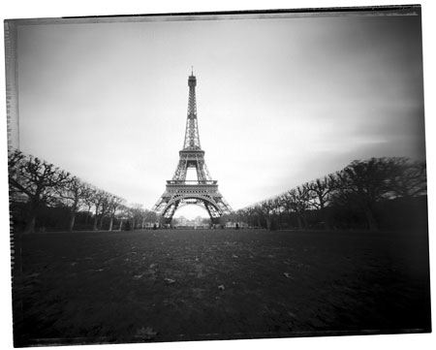
For this project, you are to create a pinhole camera out of a shoebox with your partner and make two unique completed photographs of different subjects/ backgrounds. Think of the various elements and principles of art for a dynamic composition!

Bear in mind the following information:
- The initial photograph that you are taking with the pinhole camera is a paper negative. You will then take that and make a contact print, just as we did with your photograms, for the final print.
- There will be some trial and error involved with the making of the paper negative, as it’s an imperfect science. The time will vary from pinhole camera to pinhole camera, depending on the light condition and how it’s constructed, so there’s no specific time down to the second of exposure time, just general time frames. You may have to experiment a few times to get the right exposure, which is why you must keep a record of your times.
- The brighter it is outside, the less time is needed.
- The darker it is, the more time you need.
C. The size of the pinhole (the Aperture) also determines how the
paper negative comes out.
1. A bigger hole lets more light in & makes the exposure
quicker, but the image will not be very sharp.
2. A smaller hole lets less light in & it will take longer to
make an exposure, but the image will be sharper.
- If your original paper negative is white or has only a faint image:
- The paper may have loaded backwards in the camera.
- The shutter was not open during exposure.
- The exposure time was too short.
- If your original paper negative is too dark or black:
- The camera may have a light leak. Find the additional light sources on the camera and cover with duct tape.
- The paper may have been exposed to white light.
- The exposure time was too long.

You will be graded based on the following:
Time on task- 10 points Construction of Shoebox- 20 points
Developing Quality of Prints- 20 pts Print Quality- 20 points
Creativity of Photograph- 20 points Matting- 10 points

Name: Pinhole Camera Time Records

Subject Exposure Conditions (Sunny/cloudy?) Exposure Time

______________________ _______________________________ ____________

______________________ _______________________________ ____________

______________________ _______________________________ ____________

______________________ _______________________________ ____________

______________________ _______________________________ ____________

______________________ _______________________________ ____________

______________________ _______________________________ ____________

______________________ _______________________________ ____________
Suggested Exposure Times:
Shade: 1:40- 3:00 minutes or longer Sun: 30 seconds- 1 minute
Direct Sun: 8- 15 seconds

Paper Negative Exposure Times (KEEP YOUR PAPER NEGATIVE SAFE!)
Subject Exposure Aperture (f4?) Exposure Time

_____________________________ ______________________ ____________

_____________________________ ______________________ ____________

_____________________________ ______________________ ____________

_____________________________ ______________________ ____________

_____________________________ ______________________ ____________

_____________________________ ______________________ ____________

