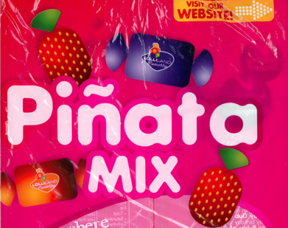 | Accounting Activity:  Pinata's Fruit Stand  Costing Inventory

Objective:
This lesson is a way to teach the abstract concept of Cost of inventory Sold in a more concrete format.

Supplies Needed:
3 snack Ziploc bags for each group
½ packet of Piñata mix for each group

Preliminary Planning:
Prior to the lesson, label and fill the bags as follows for each group-
- January 1 Inventory - Various Piñata mix -approx. ¾ or ½ packet
- Purchases - Various Piñata mix. ¼ or ½ packet
- Inventory Sold - Empty

Instructions:
Students move into groups of four and complete the work sheet below. The teacher facilitates each step

Step 1:
Give each group the January 1 inventory bag and have students count and calculate January 1 inventory.

Piñata’s Fruit Stand
January 1 Inventory
Picture | Inventory | No: | X | Price unit | = | Total $
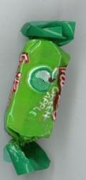 | Apples |  |  | $1
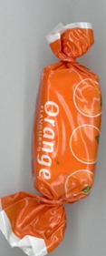 | Oranges  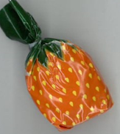 |  |  | $2
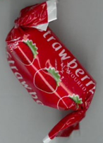 | Strawberries  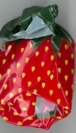 |  |  | $3
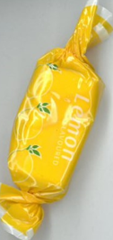 | Lemons |  |  | $4
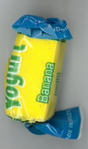 | Bananas |  |  | $5
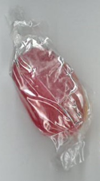 | Boiled lollies  (Varied) |  |  | $0.50
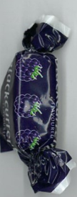 | Blackcurrant |  |  | $1.50
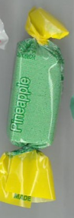 | Pineapple  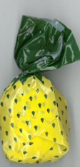 |  |  | $2.50
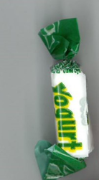 | Coconut |  |  | $0.45
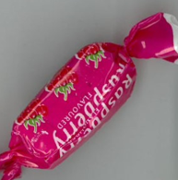 | Raspberry |  |  | $4.50
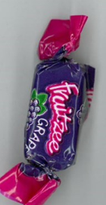 | Grape |  |  | $3.50
 | Miscellaneous |  |  | $0.10
Total Inventory for January 1 |  |  |  |  |  |  | $

Step 2
Give each group a Purchases bag and have students count and calculate Purchases and Total Cost of Inventory Available for Sale.

Purchases
Inventory | No: | X | Unit price | = | Total $
Apples |  |  | $1.90
Oranges |  |  | $2.80
Strawberries |  |  | $3.70
Lemons |  |  | $4.60
Bananas |  |  | $5.50
Boiled lollies |  |  | $0.70
Blackcurrant |  |  | $1.40
Pineapple |  |  | $2.30
Coconut |  |  | $0.40
Grape |  |  | $3.20
Raspberry |  |  | $4.10
Miscellaneous |  |  | $0.05
Total purchases |  |  |  |  |  |  | $

Total purchases | + | Total inventory (January 1) | = | Total cost of inventory available for sale *

Step 3
- Have students put a handful of Pinata lollies into the empty Inventory Sold bag.
- Calculate Cost of Inventory Sold using Weighted average and FIFO costing methods for each type of inventory.
- Calculate the total Cost of Sales on inventory sold.

 |  | FIFO |  |  | WAC
Inventory | No sold | Cost of inventory sold | Closing inventory  (No. inventory left) |  | Cost of inventory sold | Closing inventory
Apples
Oranges
Strawberries
Lemons
Bananas
Boiled lollies
Blackcurrant
Coconut
Pineapple
Grape
Raspberry
Miscellaneous
# Total FIFO  sold $ |  |  |  | # Total WAC sold $

Step 4
Calculate the new total for inventory available for sale

 | Total cost of inventory available for sale (open bal) * | - | #Total inventory sold | = | ^Total inventory available for sale (close bal)
 | $ |  | $ |  | $
FIFO
WAC

Step 5
Transfer the total of the inventory sold to the Income Statement extract provided.

Pinata’s Fruit Stand
Income Statement (extract)
As at 30 June ______

 | FIFO | WAC
Income | $ | $
Sales | 550 | 550
^Less Cost of Sales

Gross Profit

Question:
Identify which inventory costing method shows a higher Gross Profit figure.

